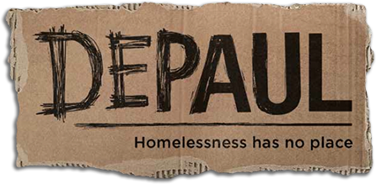

Depaul’s Your Chance Programme
Evaluation Report
“[My Your Chance support worker] has changed my life around completely. I never thought I would have seen my 21st birthday. I’m not going to lie I seriously would have been an alcoholic, druggie or dead. It’s the best service I’ve ever engaged in”

Richard Donaldson

FivewaysNP Ltd
July 2018

Contents
- Executive Summary 5
- Introduction 8
  - Depaul 8
  - The Fair Chance Fund 8
  - Fiveways 8
- Evaluating Your Chance 9
  - Evaluation objectives 9
  - Evaluation method 9
- Key elements of the Your Chance project 10
  - Target audience 10
  - Objectives 10
  - The Your Chance approach 12
  - Support to achieve accommodation outcomes 20
  - Support to achieve educational outcomes 22
  - Support to achieve employment outcomes 22
  - The referral process 22
  - Assessments 23
- Issues encountered during the implementation of Your Chance 25
  - Drop outs and disengagement 25
  - Obtaining evidence of outcomes achieved 27
  - Balancing staff resources with support needs 28
  - Using the Outcome Star 29
  - Bringing the project to an end 30
- The profile of Your Chance participants 32
  - Priority segments 32
  - Needs identified at the first risk assessment 35
  - Situation on referral 38
- Overview of outcomes achieved 39
  - Outcomes achieved and financial performance 39
  - Outcomes achieved per participant 39
- Accommodation outcomes 41
  - Outcome criteria and evidence required 41
  - Accommodation outcomes achieved 42
  - 12 month sustained accommodation outcomes by priority segment 42
  - Reasons for not achieving accommodation outcomes 43
  - Factors influencing the achievement of accommodation outcomes 44
- Education and training outcomes 48
  - Outcome criteria and evidence required 48
  - Education and training outcomes achieved 48
  - Reasons for not achieving education and training outcomes 49
  - Education and training outcomes by priority segment 49
  - Factors influencing the achievement of education and training outcomes 50
- Employment and volunteering outcomes 52
  - Outcome criteria and evidence required 52
  - Employment and volunteering outcomes achieved 52
  - Reasons for not achieving employment and volunteering outcomes 53
  - Employment and volunteering outcomes by priority segment 54
  - Factors influencing the achievement of employment and volunteering outcomes 54
- Additional project outcomes for clients 57
  - Offending rates 57
  - Improved mental wellbeing 58
  - Increased resilience 58
  - Improved relationships and support networks 59
  - Healthier lifestyles 59
  - Increased engagement in the community 59
- Additional project outcomes (Depaul) 60
  - Working on a PBR project 60
  - Staff development 61
- Client satisfaction 61
  - Client feedback for improvement 62
- Housing First 63
  - Housing First and Your Chance 64
- Conclusions and recommendations 66
  - Maximising engagement 66
  - Maximising “hard” outcomes 66
  - Achieving “soft” outcomes 66
  - Enhancing the process 67
  - Variations between groups 67
  - A successful approach 68
- Epilogue 69
Appendix: Data analysed as part of this review 70

- Executive Summary
The Your Chance Project (January 2015 to December 2017) aimed to support vulnerable, homeless young people aged 18-24 to find stable accommodation and access education and employment.
Fiveways were commissioned by Depaul to conduct an evaluation of the project to clarify what was delivered and achieved, identify key points of operational learning, and determine the factors that contributed to and inhibited success.
The evaluation included a review of project documentation, analysis of participant level project data, interviews with 12 participants, and discussions with 6 support workers, 2 representatives from referral gateways, and the project manager.
216 young people participated in the Your Chance project across four local authority areas (Greenwich, Manchester, Oldham and Rochdale).
Participants were offered intensive, tailored, sustained and accessible one to one support from a support worker dedicated to helping them towards achieving stability and progress in their lives.
The project was funded through a social investment bond, where the cost of the service provided to young people was paid for by social investors. Investment was made on a Payment by Results (PBR) basis and investors stood to lose their money if specific assessment, accommodation, education or employment outcomes were not achieved.
The project exceeded its targets in terms of number of outcomes achieved and the financial value generated for investors by those outcomes.
Of the 216 participants, by the end of the programme:
- 201 (93%) achieved at least one accommodation, education or employment outcome
- 162 (75%) sustained stable accommodation for 12 months or more
- 91 (42%) were registered on a course and attended at least one session
- 37 (17%) gained a new qualification
- 57 (26%) accepted an offer of employment and attended at least one day of work.
- 30 (14%) spent 13 weeks or more in full time employment
The programme found that the longer a participant sustains their accommodation, the more likely they are to achieve educational or employment outcomes.
In addition to these PBR outcomes, there is qualitative evidence that participants also achieved additional “soft” outcomes in terms of improved mental wellbeing, increased resilience, improved relationships and support networks, healthier lifestyles, and increased engagement in the community.
These positive outcomes were achieved due to the successful implementation of the project’s holistic, personalised approach by a motivated, caring and well-supported team who had the resources to creatively address client needs and the time to develop trusting relationships. This is reflected in the high levels of positive feedback from participants.
Due to the high levels of need amongst participants there was a small proportion of the cohort whose lives were still chaotic after at least two years of support. Care leavers and those who had offending backgrounds did not perform as well as other groups. However, having a mental health diagnosis either before or during the project was not found to be a barrier to achieving positive outcomes.
The experience and learning from Your Chance have generated the following recommendations for enhancing the delivery of similar projects.
To maximise engagement
- Ensure the young person commits to receiving support during the referral process
- Use social media, particularly Facebook, to enable support workers to maintain contact with participants as mobile phone numbers change frequently
- Use events and activities to get participants together, build friendships and develop confidence
- Meet the young person in a setting they are comfortable with, and be able to buy them refreshments
- Use a “personalisation fund” to pay for everyday living costs (e.g. travel or mobile phone credit top ups), activities to promote engagement, and incentives to celebrate success. This helps to remove financial barriers to progress and build motivation for maintaining contact.
To maximise “hard” outcomes
- Ensure the “offer” to the participant comes with accommodation – perhaps by working with landlords to commit properties in advance and set aside any previous issues people may have had with tenancies
- Ensure specialist resource within the team to focus on employment, education, training and volunteering
- Map out the availability of short term, practical and vocational courses at an early stage of the project
To maximise “soft” outcomes
- Dedicate time for advocacy with housing providers, statutory bodies, the health service and others. This played a particularly effective role in stabilising young people and allowing them the breathing space to then consider opportunities
- Consider increasing the focus on mental health support by giving workers specific targets relating to mental health, providing more training, or investing in a specialist mental health worker
- Devise a means of reliably and consistently recording soft outcomes
To enhance the process
- Ensure more time to publicise the service and link in with other services in advance of recruiting participants
- Consider allowing participants who disengaged at an early stage to be replaced by others willing to engage to benefit from the opportunity
- Devise an effective process for monitoring participant engagement and disengagement through monthly data reporting
- Consider how the impact of support staff on short term contracts leaving before the end their contract could be avoided (for example using incentives.

- Introduction

Depaul
Depaul’s mission is to end homelessness and change the lives of those affected by it. Depaul UK works with some of the most disadvantaged people in the UK. It specialises in working with young people and in communities where poverty and long-term unemployment have resulted in generations of social exclusion and high rates of homelessness.
Depaul UK now supports around 3,700 people a year with an interlinked family of projects ranging from emergency accommodation through to longer-term supported housing and paths to skills, training and employment.
Between January 2015 to December 2017 Depaul UK ran a three-year project, “Your Chance”, that provided intensive support to 216 vulnerable, homeless young people in Greater Manchester (Manchester, Oldham and Rochdale) and Greenwich – helping them towards achieving stability and progress in their lives.

The Fair Chance Fund
Depaul’s Your Chance project was funded by the DCLG and Cabinet Office Fair Chance Fund launched by the Conservative and Liberal Democrat coalition government in February 2014.
The fund invested £15million into services to improve accommodation, education and training, and work outcomes for a group of young, homeless people who had unmet complex needs and circumstances.
Due to the complexity of the problems faced by young homeless people, the fund did not specify in advance how services should be run. Instead it was designed to pay for outcomes achieved. This allowed voluntary sector and other providers the freedom to innovate and adapt to achieve the best possible results and address problems that might otherwise lead to long term benefit dependency, health problems and increased crime.
Each Fair Chance project was funded by a social investment bond, where the cost of the services provided to young people was paid for by social investors. Investment was made on a Payment by Results (PBR) basis and investors stood to lose their money if specific outcomes were not achieved.
Depaul secured funding to deliver Your Chance through the Fair Chance Fund in July 2014.

Fiveways
Fiveways is a consultancy for charities that want expert help from people who know the charity sector well. We are passionate about finding practical solutions to the issues that prevent charities from achieving more and working with clients to identify and implement the changes required to increase their impact on society.
We specialise in strengthening charity governance, assessing and managing risk, and evaluating projects and services to drive future improvement.
- Evaluating Your Chance

Evaluation objectives
The evaluation was aimed at meeting the following objectives:
- To define the overall approach to Your Chance
- To examine the implementation of the project and identify key points of operational learning
- To determine what Your Chance achieved in terms of PBR outcomes
- To determine what Your Chance achieved in terms of additional, non PBR, outcomes (i.e. improved mental wellbeing, improved relationships and support networks, healthier lifestyles, increased engagement with local communities, increased resilience)
- To determine the factors that contributed to and inhibited achieving those outcomes

Evaluation method
The following research activities took place to develop the insight to meet the above objectives.
- Review of project documentation (e.g. board reports, board minutes, project briefings)
- Review of participant level project data captured on Depaul’s “In-Form” database (see Appendix 1)
- Interviews with 12 young people who participated on the programme (9 face to face interviews and 3 by telephone; 7 from Greater Manchester and 5 from Greenwich). Young people were incentivised to take part in the evaluation with a £10 shopping voucher
- Discussions with 6 support workers (3 in a mini focus group, 1 face to face interview and 2 by telephone)
- Interviews with 2 representatives from referral gateways (by telephone)
- 2 telephone interviews with the project manager
- Ongoing liaison with the project’s data officer

- Key elements of the Your Chance project

Target audience
The following people were eligible to be supported by Your Chance (i.e. Outcome payments were only able to be claimed for young people who met these criteria):
- Young people aged 18 to 24 years old (or 21 and over if they are care leavers)
- Not in employment, education or training
- Homeless but not in priority need, or
- Homeless in priority need but unable to stay in supported accommodation (due to reasons including previous difficulties or eviction from supported accommodation, security issues, needs being deemed too high or complex, or lack of specialist supported accommodation)

Objectives
At the outset the project expected to help more than 85% of participants to move into stable and appropriate accommodation, 35% to engage in education and 40% to enter employment.
The project’s objectives were revised twice during the three years (September 2015 and May 2016) as the number of starters increased and the project learnt more about what was achievable (this will be discussed below). The original and final PBR objectives for the project are shown in the table below, along with the proportion of participants targeted to meet that outcome, the amount that could be claimed for achieving and evidencing each outcome, and the total target revenue.

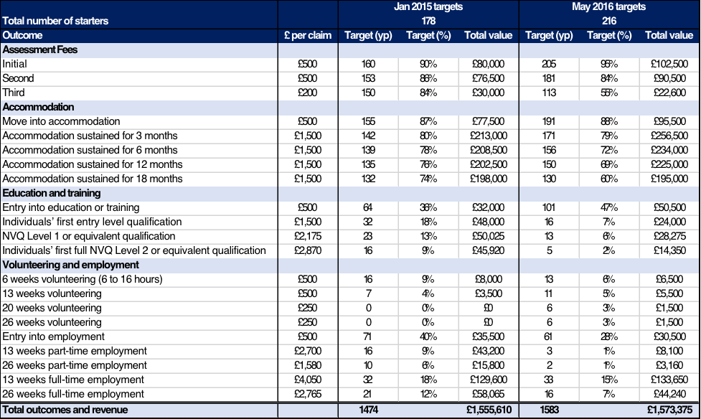
In addition, Depaul aimed to achieve the following “softer” outcomes (not covered by PBR payments) for young people through the Your Chance project:
- Improved mental wellbeing
- Improved/stronger relationships and support networks
- Healthier lifestyles (including reduced use of drugs and alcohol)
- Increased engagement with local communities
- Increased resilience

The Your Chance approach
Depaul’s model of support is based on an asset-based approach which incorporates:
- Psychologically Informed Environments (an awareness of the mental health problems of the homeless people using services, and how the environment may affect their mental health positively or negatively)
- Attachment Theory (fostering positive relationships and helping youth to model positive relationship and social skills).
The Your Chance project reflected this approach and was underpinned by the following features:

Support was flexible, holistic and tailored to meet individual needs
The Your Chance approach required support workers to be flexible and creative in how they provided support. The team were made aware of what PBR outcomes needed to be achieved but how they were achieved was up to the worker. In the words of the project manager “they had their wings and could do what they wanted”. They were also able to switch approach if something wasn’t working.
“All I got when I started were the contract requirements. It was a blank sheet of paper. I had the flexibility and resources to do things differently and get results” [SW2]
“The government’s agenda is around personalised care and person-centred approaches. This programme was amazing at that. I haven’t seen any other service that is able to provide that wrap around support or tailor-made personalised care” [SW1]
One example of this flexibility is the location where support workers would meet young people, such as their homes, or in local cafes or fast food restaurants.
“[Support worker] was very patient making sure they provided a useful role such as waking [Client] up for appointments and going to [the client’s] flat for support sessions rather than relying on him to meet him elsewhere – when there was high chance they wouldn’t turn up.” [Board report case study].
“If people didn’t want to travel to the [office] staff could go to them – at McDonalds, Starbucks – whatever suited them.” [SW2]
“If you are tied to an office you don’t have that luxury of getting out and spending time with young people” [SWG]
“The hostel wasn’t a nice place – it was nice to have someone to come and take you away from it.” [C11]
Your Chance recognised the need to support young people to break through the personal and practical barriers to achieving the desired outcomes. Often these barriers were not directly related t0 housing, education or employment. For example, barriers may have included poor mental health (e.g. anxiety, depression, low self-esteem), lack of money management skills, or issues with drug or alcohol use.
As opposed to being focussed solely on resolving a single issue such as the need for housing, support workers were able to look holistically at the young person’s needs and work intensively with them to help them overcome whatever barriers they faced. Through building strong relationships, workers were able to tailor their support to the individual needs of each young person.
Support workers described this as working “in the grey areas” – i.e. the aspects not covered by existing services often because staff in those services don’t have the time.
“If people are waiting for accommodation they are often floating around with no one to support them. They’ve been placed in a B&B, with no benefits, no food, no clothes, nowhere to wash their clothes, no-one to help them with their appointments. Nobody would be there for them, they have no support, they are by themselves – that’s where we came in” [SWG]
“There is a gap there - there is a cohort of young people that do have additional needs that require that extra support. We have kids with schizophrenia in B&Bs getting kicked out without a worker to intervene and take them to their appointments. It is needed.” [RG2]
“You didn’t have to say no – you could support young people with whatever they needed” [SWG]
“Whatever barriers were in front of them you were there to work with them and unpick those barriers – going to mental health assessments, benefits assessments, job centre appointments, anything, helping them to clean their flat, go shopping, you are able to do all those little bits in between rather than saying ‘there’s a job interview, go – good luck’” [SWG]
An interviewee from a referring gateway mentioned that this approach was sometimes hard to “sell” to a young person at the outset. It is noted below that the effectiveness of this initial sell may have affected subsequent engagement of the young person (see 5.1.2).
“From the young person’s perspective, on the surface Your Chance does not offer them anything – they want somewhere to live” [RG1]
As a result of this flexible, tailored approach, the workers provided a wide range of holistic support, for example:
- Work aimed at improving low level mental health issues, such as organising walking groups
- Linking young people with local providers of mental health support and helping clients to engage with them
- Providing CBT (Cognitive Behaviour Therapy) counselling, funded through the personalisation fund (see 4.3.6 below) for young people for whom usual mental health routes were not working, or who couldn’t manage regular engagement.
- Providing food parcels or vouchers to pay for gas, electricity and furniture
- Support to obtain identification documents
- Ensuring attendance at meetings
- Advocacy to reinstate benefits payments, appeal fines or clear arrears
- Support to understand how to pay Council Tax or utility bills
- Registering with GP practices
- Ensuring compliance with medication
- Referring to other specialist services (e.g. drugs and alcohol, child sexual exploitation, debt advisers)
- Acting as the lead professional with other agencies (e.g. probation services) to provide “joined up” support
- Providing wake up calls to support attendance at meetings
This holistic support is also revealed by the following case studies and quotes from interviews.
“I know one worker went to the gym with the client. That’s not housing, or employment education or training – but it is a start – it is about physical health, confidence, being in a social setting” [RG1]
[The Your Chance Support Worker] identified the connection between the client’s mental health and a recent incident when his bike was stolen. The client used his bike as his mode of transport and through this he was able to stay fit and healthy. Without his bike, he found he was more stressed and felt less positive within himself. His Your Chance worker identified this as an action for improvement and was able to find an organisation that promotes education and a restorative approach to personal development through cycling and bicycle maintenance. The Director of this organisation was impressed with the client’s enthusiasm and offered him a volunteering position on the spot. Your Chance also decided to invest £50 in getting another bike for the client. [Board report case study]
[Client] was referred whilst on eviction notice from supported accommodation. He had not paid rent or service charge and was displaying anti-social behaviour. [Client] had been recently released from prison and had not made a claim for benefits. The accommodation provider was not aware that [Client] could not read or write and so had assumed he had set these payments up himself but [Client] did not find it easy to ask for help. [Client] worked with [Support worker] to set up his claim for JSA and also backdated HB which he was successful in getting. The ASB was caused mostly by [Client] being frustrated about the lack of support he was getting, and his own anger at himself for not being able to sort the benefit situation out. Once the benefits were in payment, his behaviour improved and [Client] was allowed to stay in the accommodation. [Board report case study]
“[Support worker] kept me on track with appointments – she would ring me up to remind me and if I had forgotten she would take me there.” [C8]
In interviews, most young people mentioned how much they appreciated the support worker coming with them to meetings and advocating on their behalf.
“[Support worker] came to meetings, the doctors – she talked to Mum, came with me to the sexual health clinic” [C3]
“The way [Support worker] put my story forward, she was really professional.” [C4]

Support was available when needed
Support workers were available to offer support when the young person wanted it, including at evenings and weekends. As young people progressed through the programme, the amount of support they required may have lessened but the project was prepared to increase the support should their situation change. Support was also available to those who had left the programme but wished to return and those who were in custody.
“I was there whenever they needed me and that was the key. With Your Chance I could get up at 6am to make sure they were at appointments on time”. [SW3]
“We worked the hours required by the young person. For example, I took someone in crisis to a place of safety in the evening – I had that flexibility. That’s different from structured support at certain times and days of the week – what if you are in crisis outside those times?” [SW1]
“If I was working elsewhere I might have to say to a young person ‘I can’t go there with you - I’m not on shift that day or I’m on duty that day” [SWG]
The Your Chance support workers continued to support young people when they were struggling or if they experienced setbacks. The team demonstrated high levels of motivation and dedication and often “went the extra mile” for their clients - as is borne out by the following case studies and quotes from interviews.
“[Client] has already had set-backs while on Your Chance - split up with her partner and went on a drinking binge which left her hospitalised due to epileptic fits and blackouts. [Support worker] visited her when released from hospital and she commented that she thought [Support worker] would stop working with her when she ‘messed up’ (her words). [Support worker] has been able to explain the difference in this programme, that we understand she will experience ups and downs, but that [Support worker] will continue to support her if she wants them to. [Client] says she needs some stability with professionals who work with her.” [Board report case study]
During this time, [client’s] mood dramatically declined to the point where he texted his Support Worker saying ‘I don’t know how much longer I can go on with all this stuff on my mind. I am in bits”. [Client] needs constant support with his mental health and risk of self-harm and the relationship that he has with his Support Worker contributes massively to his success and resilience. Without that support [Client] may not be in the position of security he is now. His Support Worker is able to meet [Client] whenever he is feeling low to remind him of all the positives and progress he has made. [Board report case study]
“The best bit was having someone there that I can always speak to, that you can rely on and who knows the system. He always tried to minimise stress levels the best he could. Even if he was really busy one day but you needed him he’d come.” [C12]
“[Support worker] was amazing, anytime I needed her she was there for me – for anything. Even if it was the most littlest thing, she was there… I could call her anytime. I couldn’t ask anyone else because I didn’t have anyone else.” [C1]
“The way she showed she cared, she wasn’t working for the money. She was working for the young people themselves. She went out of her way to help me, she would meet me on days she wasn’t working. She went the extra mile” [C4]
“He was about to finish work but he stayed overtime [to deal with British Gas], bless him, because he wanted to make sure I had gas on my meter” [C11]

Support was provided over an extended period
The Fair Chance Fund provided the Your Chance project with a longer opportunity to work with young people (between 2 and 3 years depending on when the young person was referred) than is usually available under typical statutory contracts. As well as allowing space for the holistic, flexible approach described above it also gave support workers time to build trusting relationships with young people and, therefore, more opportunity to achieve desired outcomes.
[Client] was initially hesitant to meet with his worker, saying he had had enough of services and having to tell his story to other professionals only for them not to be able to do anything to help. It took [Support Worker] several attempts to meet with the young person and realised he needed to take things very slowly in order to build a positive relationship. [Client] refused to complete his assessments – again [Support Worker] realised he would need to engage him with other activities before they could focus on what support he needed. [Support Worker] and [Client] would meet in McDonalds and then go to the gym as [Client] wanted to learn to box –in doing this on a weekly basis [Support Worker] was able to build a relationship and have informal support sessions. [Support Worker] discovered [Client] could not read or write, and this was another reason he was unhappy completing paperwork. [Support Worker] also suspected underlying mental health and behavioural needs that had not been detected due to [Client] not wanting to engage with services. He has now accepted a referral to the mental health team and is also working with our family mediation team to enable him to live with his auntie as he had been asked to leave several supported accommodation projects for fighting.[Support Worker] has also been able to encourage [Client] to engage with the benefits process, helping him with forms he was before unable to complete. [Support Worker] has also supported [Client] to engage with a basic reading and writing course and is helping him in support sessions to develop this. [Board report case study]
“It gave you the time to do the job you needed to do with that young person – I felt satisfied I had done a good job and had an impact on the young people because I had had the time to do it” [SW3]
“We had time to see pieces of work through. We’ve all worked in accommodation services, if a young person leaves accommodation negatively we have no more contact with them unless they are referred back into the service. If it is planned, you will support them for another four weeks after they leave and that’s it. So, you may have built up a good rapport but then it ends and the young person is left to build a new relationship with the next person, or they are on their own in a tenancy. You think ‘I wish we could do more’, but you don’t have the capacity to do that because there are other people coming into the service.” [SWG]

“Parental support”
The fact that the support provided was holistic, constant and prolonged led clients, support workers and others to describe Your Chance as the support a parent or other family member might give – support that some young people might never have had.
“Basically, she comes up with things that solve your life. I don’t know how – maybe it is because she is a Mum.” [C8]
“They helped me as a person, things that maybe parents should have taught you” [C3]
“I used to call him my grandad, that’s how close I felt like I was with him.” [C12]
“It was like being a professional family member – someone consistently with them [clients], someone who stayed beside them and took them to the next opportunity.” [SWG]
“Your Chance did the stuff you would do with your own kids – they took a Corporate parenting role – ‘have you done this? Have you done that? Don’t forget you’ve got that interview today’” [RG1]
This is not to say that workers created a dependency with young people. As will be expanded on below, staff maintained professional boundaries and were clear with clients about the time over which support would be provided. Significant work was also undertaken in years 2 and 3 to “taper off” support (see 5.5.1).

A focus on engagement
Whilst recognising that each young person might want, need or accept different levels of support, the Your Chance project understood the importance of maintaining regular contact with young people and set expected engagement and activity levels across the cohort of participants.
- During the first year of the project, at least 80% of clients were to engage in any month, through face to face meetings or phone/text contact with their support worker.
- There should be some form of contact each week with all engaged clients - at least a phone/text contact, and a face to face meeting at least once a fortnight.
Strategies employed to increase engagement (as well as to achieve the projects’ desired “soft” outcomes) included:
- Group activities such as mindfulness and reflexology sessions, a fishing trip, cooking activities, trips to local museums, forming a running club, and a trip to visit Depaul’s work in Bratislava, Slovakia.
Client A has got involved in all activities that are offered to her such as dance class, parkour, roller disco and football which have increased her confidence and wellbeing dramatically. [Board report case study]
- Celebrating achievements. Incentives were given when young people achieved certain personal targets. However, support workers were careful that this was not seen as a bribe. Instead, in the words of the project manager, “if people did well we might reward them like a parent might” for example taking them for lunch, or contributing towards driving lessons, gym memberships, a new phone or item of clothing.
- Meeting up in social environments. As noted above support workers were able to say to young people “let’s go for a coffee or to McDonalds”. This was thought to be preferable in terms of increasing engagement to having to meet in more sterile office environments.
“They [Your Chance support workers] were able to spend time building a relationship so the Your Chance worker would be more successful in any intervention that needed to be made. Rather than being in an office they would go for a chat in McDonalds. That’s when the young person opens up – you can build a relationship, they say things they never said in an assessment.” [RG2]

Access to a “personalisation fund”
Your Chance Support Workers were able to access a fund to pay for:
- Clients’ everyday living costs (e.g. food, travel, helping with bills, contributing to paying off arrears and mobile phone credit top ups).
- Activities to promote engagement and achieve desired outcomes, such as CBT support, work ready programmes, refreshments, and the activities mentioned above
- Incentives to celebrate success
“Help with bus fares got me to college, otherwise I would have had to walk for hours” [C9]
“One client did an art and drama course – she needed money for a leotard and dance shoes, we also paid for a photoshoot for a portfolio. That had an amazing impact on her wellbeing and her progress as nobody had bothered before, she was stuck.” [SW3]
“Having the resources to hold these activities helped to build trust between the young person and worker. There were better levels of respect – you had the time to talk and listen.” [SWG]

On average spending per person from the personalisation fund was £409.88.

A skilled, motivated, well supported and trusted staff team
The project was implemented by a team consisting of the following roles. The size of the team expanded from a starting point of 9.1 FTE (full time equivalents) to a peak of 15.9 in September and October 2015. The team was maintained at 15.7 FTE between November 2015 and June 2016 and then reduced gradually to the end of the project (6.6 FTE).
Role | Range of FTE
Programme Manager | 1
Senior Support Workers | 1.5-2.5
Support Workers | 2.5-11
Performance Management Analyst | 1
HR support | 0.4
Finance support | 0.2

The Your Chance team of support workers was a mix of new and existing Depaul employees. There was often strong demand for Your Chance roles because the pay grades for the Fair Chance programme were at a slight premium to the standard levels.
From the outset, the team was required to adapt previous working practices in two distinct ways:
- The project required them to work in a more proactive, flexible and creative manner
- They needed to be comfortable with PBR outcomes achievement being at the core of the project
During the project the team also had to adapt to the changing nature of the support required over the duration of the project. In the first year their primary focus was stabilisation and accommodation. However, as young people progressed, this focus changed to supporting employment, training, education and sustainment. For example, the role of senior support worker changed from dealing with referrals and networking with referral gateways in year one to supporting the sustainment of education and employment opportunities in years two and three.
Staff received comprehensive training and induction, including mediation training (with a focus on mediation between families) and understanding Novel Psychoactive Substances.
The project recognised the stressful nature of the support worker role and implemented activities to ensure the team was effectively supported.
The staff team in the North West completed a series of three reflective practice development sessions and six support workers accessed external clinical supervision. The team reported that both these interventions helped them manage their stress levels and challenging caseloads.
“Depaul is very supportive of staff. It is an ‘employer of choice’. Staff feel valued and supported and deliver a better service. We had a supervision every 4 weeks, which was not missed, and welfare calls. There was minimum sick leave. Staff committed to going above and beyond. The project worked because of what the organisation is and does”. [SW1]
“We knew the ultimate goal but however you achieved it was up to your creativity. We were trusted to do it. Our manager trusted us, and we trusted our manager – so we just got on and did it.” [SWG]

Support to achieve accommodation outcomes
Your Chance support workers offered a range of services to help clients find and sustain accommodation. This support included:
- Mediation with families – either provided by support workers or Depaul’s dedicated mediation worker supporting clients in Oldham.
“Staff have explored options of living with family. [Client’s] granddad has offered him a room on the understanding that he engages with us [Your Chance] to find more suitable long-term accommodation, works to pay off his debts and address his anger management issues. These are all topics on his support plan.” [Board report case study]
- Advocating on behalf of the client. Advocacy and attending meetings were a key part of the support provided by workers across the Your Chance project. In accommodation it was used to:
  - allow those facing eviction notices to stay in accommodation as they were now being supported by Your Chance
  - ensure clients remained as priority cases on housing registers
  - ensure assessments by Supported Accommodation teams took place
  - allow clients to bid for social housing properties
  - negotiate with landlords
“If you don’t have someone advocating for you it is very difficult to access services – having this advocacy makes so much difference.” [SWG]
"[Support worker] met with [client’s] probation worker and local housing board to put forward the case for him to be awarded his own tenancy due to his situation and vulnerability, arguing that with Your Chance support there would be less chance this would fail. The LA agreed and [client] moved into his own flat.” [Board report case study]
[Client] had an interview for a housing association flat but was refused this when she disclosed that her family had been tenants when she was an early teen and her parents had caused anti-social behaviour and were asked to leave. [Support worker] appealed this decision, arguing that the anti-social behaviour was due to her parents rather than her. [Board report case study]
[Client] was referred whilst on eviction notice from his general needs tenancy he had held since he was 16 (5 years). [Client] had got into debt with his rent and would not let the housing provider in to address some repairs that were needed. What [Support worker] discovered was [Client] had mental health issues that had gone undetected for some years, he had developed hoarding behaviour and his flat was in a real state. [Support worker] liaised with his landlord and the courts as [Client] was due in court in three weeks. [Support worker] requested a mental health assessment. He also helped [Client] apply for benefits again, his claim had lapsed as he was too anxious to leave the house to sign on. [Support worker] supported him to claim ESA. Although the landlord was keen to evict, [Support worker] was able to speak for [Client] in court and he was allowed to stay. [Support worker] and another worker also hired a skip and went to [Client]’s flat to help him clean in and get rid of some of what he had hoarded. [Client] is now getting support for his mental health need but continues to have problems with his landlord – [Support worker] continues to support him with this. [Board report case study]
- Exploring alternative accommodation options, for example in the private rented sector
- Helping to access emergency accommodation
“[Client] was picked up by [Support Worker] from prison and taken to the Local Authority emergency accommodation night shelter.” [Board report case study]
- Providing help to clean homes and find second-hand furniture as well as providing move-in packs for clients moving into accommodation.
- Placing clients on pre-tenancy courses to develop the skills necessary for independent living, such as debt and benefit management. Once completed, these courses helped to demonstrate a young person’s ability to manage a tenancy and increased their chances of securing accommodation in social or private housing.
- Supporting young people to reduce rent arrears by setting up repayment plans with them and assisting them with benefit sanctions.
- Providing rent deposits for young people moving into the private rented sector or social housing.

Support to achieve educational outcomes
To meet educational needs, Support Workers would support young people to:
- Access courses for example those run by the Prince’s Trust, Sport for Change (sports leadership), or Make a Change Abroad.
- Obtain the relevant certification for their skills (e.g. the CSCS card which provides proof that individuals working on construction sites have the required training and qualifications for the type of work they carry out).
- Sustain their education through advocacy with colleges and other training providers

Support to achieve employment outcomes
In employment, support workers and the project’s dedicated employment staff (see below 9.5.2) helped young people to:
- Identify suitable options and submit applications for jobs, supported placements, work experience or volunteering.
- Write CVs and prepare for interviews (the project ran “drop-in” job-clubs for clients to get assistance applying for jobs and general advice on employment opportunities)
- Purchase clothes for interviews or work (from the personalisation fund – see 4.3.6)
- Access the Ready to Work programme run by Back on Track, involving initial training and a skills audit, then a two-week work placement, with the possibility of a job offer at the end of the course.
- Sustain their employment
“I just needed someone to take the time to help me sort out getting my ID and writing a CV, I just didn’t know where to start. My support worker helped me focus and now I am looking forward to starting college and hopefully work next year” [Client quoted in Board Report]

The referral process
Before the project started, Depaul agreed and signed a Memorandum of Understanding with each participating local authority covering the expected number of referrals, referral process, aims of the programme, and key terms of the relationship.
Each local authority nominated a “gateway” service to accept referrals for Your Chance. Referrals could come from any source, but they had to be processed through the gateway.
Before the project started, the Your Chance team did extensive networking to promote the service to local agencies who may not normally refer to the gateway or who may be working with people who had had a bad experience of a gateway.
Following a referral being received:
- The gateway service would assess the young person and identify them as suitable for Your Chance.
- The Local Authority would then “sign off” on the referrals confirming that the person was eligible and a suitable referral. Depaul was not able to refuse a referral from a gateway to ensure they could not “cherry pick” the young people they worked with.
- Within 24 hours of sign off the Your Chance team would attempt to contact the young person to start the relationship.
Referrals for Your Chance were only accepted during 2015 starting from 19th January and ending on 31st December.
Referral gateways looked to make it easy for other organisations to refer to them.
“Referrers don’t want to do anything complicated – I felt they wouldn’t do an additional referral form. They’ve got a homeless young person in front of them and their first priority is to get a roof over their head – Your Chance was secondary to that as they didn’t have any accommodation.” [RG1]
“Our main focus was to get them [the clients] a place to stay – if they had additional needs we would say ‘you will get a worker to support you with those’. Your Chance could do the stuff that is necessary to do with those clients that we aren’t able to do because we don’t have the resources because of staffing cuts” [RG2]
“The benefit for referrers was that Your Chance had the capacity to go to appointments with people. We said, “This is going to save you lots of time – If you’ve got Your Chance the young person is more likely to stay in that accommodation because they have got the wrap around support.’” [RG1]

Assessments
Three outcome payments could be claimed for completing assessments with the client; one upon initial referral and acceptance into the programme, and two additional assessments within the first nine months on the scheme. There needed to be at least a 10-week gap between each assessment.
The aim of the assessments was to track progress and identify changing support needs. The Homelessness Outcome Star was used to undertake the assessments. It is a tool used to measure a client’s engagement with dealing with any issues they may be facing (rather than the severity of the need).
The ten issues or “domains” covered by the Outcome Star are: Motivation and taking responsibility; Self-care and living skills; Managing money and personal administration; Social networks and relationships; Drug and alcohol misuse; Physical health; Emotional and mental health; Meaningful use of time; Managing tenancy and accommodation; and Offending.
Through detailed discussion, staff and service users agree a score from one to ten for each of the domains. This places them on the ‘Journey of Change’, which consists of five stages and relates to service users’ ability to deal with issues independently:
- Stuck (scores 1-2): Service user is far away from achieving their potential, unable to accept problems or accept help.
- Accepting help (scores 3-4): Service user acknowledges problems, wants thing to be different and accepts help some of the time.
- Believing (scores 5-6): Service user starts to believe that they can make changes in their life and takes some initiative to do things differently.
- Learning (scores 7-8): Service user becomes more confident in themselves and their ability to achieve their goals.
- Self-reliance (scores 9-10): Service user becomes self-reliant and can cope with challenges without help.
Once scores have been agreed for each domain, they are plotted onto a tool which creates a star shape to be used as a visual aid for clients. Scores from subsequent assessments are mapped out on the same diagram so that clients can see their progression over time.

- Issues encountered during the implementation of Your Chance
This section explores some of the challenges faced when implementing Your Chance and how the project sought to resolve them.

Drop outs and disengagement
Despite plans and actions to maximise clients’ engagement with Your Chance (see 4.3.4 above) some people did not engage fully with the service. After a certain period of disengagement young people were “archived” and responsibility for attempting to continue contact transitioned to Senior Support Workers.
Some of these clients were archived for positive reasons such as those that no longer required intensive support from their support worker, who were living in stable accommodation and may have been studying, working or in training. The project found that engagement with clients after they moved into or between stable accommodation was a key challenge. This made it difficult both to provide ongoing support and to evidence accommodation sustainment outcomes, even if these are achieved.
However, some were archived for negative reasons including people who moved out of the area and became uncontactable, those who may have been given a long-term prison sentence, and those who refused all contact attempts by support workers. Some of these people may have been in stable accommodation and in some form of work or training but, due to the lack of contact, that could not be verified. Young people were most likely to drop out of the programme for negative reasons in Manchester and Rochdale.
During the project, the cohort was split into the following engagement categories:
- “Regular” clients are engaging and are expected to achieve outcomes over the life of the programme. There are no major issues.
- “Crisis” clients engage with the service regularly but may not achieve many outcomes due to their high level of need.
- “Limited” clients are achieving outcome and may be in EETV (employment, education, training or volunteering) but only required limited contact in order to be supported.
- “Disengaged” clients do not respond to contact attempts. This includes those clients who have moved out of area or are serving prison sentences
This was considered an effective way to categorise engagement as it explained whether support was low because the participant was settled (limited) or because they had disengaged. In January 2017 27% of the cohort (60) were in the “limited” engagement category and 13% (28) were in the “disengaged” category.
One additional factor that did not help support workers was the rate at which some clients changed their mobile phone number (one young person had over 20 numbers during the project). If the support worker was not aware it had changed they were left without their main channel of contact.
In addition, the Manchester project found that participants would disappear into the city’s homeless camps and not be contactable.

Steps taken to address disengagement
To address this challenge the team implemented additional activities to prompt engagement including:
- Attempting to reach the client through other agencies they may have been involved with. In some cases, the level of service continued in periods when clients were not engaging as their support worker would still advocate on their behalf, and/or attend multi-agency meetings.
[Support Worker] tried to keep contact through phone calls / texts and going to the flat but [client] would not engage with him. [Support Worker] kept contact with the accommodation provider and other agencies working with [Client] (e.g. probation) to check on his progress and also increase his chances of being able to meet with him.
- Opening drop-in “hub” for the North West teams to both support continued engagement and encourage access to employment, education, training and volunteering (EETV) options.
- Some workers felt that social media could be used more to communicate with clients. It was used in Your Chance on a limited basis for the group who visited Bratislava and was considered to have been successful as it overcame the problem of young people changing their phone numbers. The reason provided for not using social media more extensively was a concern about on-line bullying therefore, if it was to be used more, sufficient safeguarding systems would need to be in place to protect clients.

Factors influencing participant engagement
- The referral process
The quality of the referral process and how young people were introduced to the project seems to have had an influence over young people’s engagement with the service, particularly with “early drop outs” – i.e. clients who dropped-out of the programme before moving into accommodation.
Greenwich saw much higher engagement rates because, rather than being told they were going to receive support through Your Chance, as part of the referral process young people were informed of what the support would involve. They would only be referred if they agreed to commit to the programme and to engage with support – therefore client “buy in” was higher.
The project noted that engagement rates were lower in the other local authority areas where support workers did not have the opportunity to meet the young person and discuss Your Chance with them. On occasion, when support workers contacted the young person they were not aware they had been referred and were reluctant to engage.
- Time supported by the project
Analysis during the project (October 2016) revealed that the longer a young person was supported on the programme the more likely they were to engage. As opposed to engagement decreasing with the number of months on the programme (as people became more stable), the clients who started in early 2015 had the strongest engagement rates.
This observation may also be linked to the referral process and when young people became involved in Your Chance. In the first quarter of 2o15 it was likely that those referred were already known to gateways and local authorities and, therefore, they were well-placed to judge the young person’s suitability for the programme and introduce them to the service. Later in the year less may have been known about the young people who were being referred to Your Chance having presented as homeless. By the fourth quarter a pressure to refer before the December cut off may have resulted in less suitable referrals.

Obtaining evidence of outcomes achieved
Support workers found it challenging to obtain evidence for outcomes being achieved from some agencies (e.g. Housing Associations, education providers, and employers who offered short-term, temporary positions). More details of the evidence required are given below (sections 8.1, 9.1 and 10.1).
To meet DCLG’s requirements, an evidence request needed someone in these agencies to print out an evidence form, complete it by hand, and scan it to their computer to email it back. Some agencies with limited resources or capacity may have been put off by this labour-intensive process.

Steps taken to address difficulties getting evidence
- Involving the senior support worker. Sharing data on evidence outstanding with senior support workers allowed them to help the team to track down what was needed, for example by using their existing links with other agencies. The Your Chance data analyst started to copy in the senior support worker when requesting evidence from the team. This ensured both parties were aware of what had been requested and could liaise about how best to obtain the evidence at an early stage.
- Getting evidence in person. Some agencies were reluctant to respond to requests by e-mail and phone. Another tactic used was to offer to go in person to collect evidence. Sometimes this approach encouraged agencies to send the evidence by e-mail.
- Introducing a consent form. The young people who worked with the Employment Partnerships Co-ordinator (see below 10.5.2) signed a form upfront that allowed support workers to chase evidence (e.g. pay slips) directly from employers. This ensured the young person was aware of and comfortable with the evidence collection requirement at the outset. Previously workers were unable to chase evidence without the young person’s consent (which at times was not given).
- Adapting the data analysis function to undertake more of the evidence collection and data recording to ease the burden on support workers
- Encouraging DCLG to accept e-mail exchanges between Depaul and other agencies as the evidence for outcomes rather than the form.

Balancing staff resources with support needs
To reflect the fact that the cohort of young people was planned to grow until referrals ended in December 2015, staffing resources were planned to increase during 2015, peak at the end of 2015 to mid-2016 (when support activities were anticipated to be at their highest) and then reduce from October 2016 to the end of the project (December 2017).
As noted above (4.3.2) young people were able to access support whenever they wanted. Therefore, the project had to allow some capacity in case someone who had not engaged for a lengthy period asked for support when the project was in its final months.
During implementation the project demands on the staffing resource increased for the following reasons:
- In mid-2015, there was a concern amongst investors that the initial “drop off” rate (i.e. before a young person moved into accommodation) might be as high as 20% (against an expectation of 13%). Depaul were encouraged to “oversubscribe” Your Chance and recruit 38 more starters than originally planned to ensure outcomes targets were met. However, the initial drop off rate never reached that level.
- In March 2016 the project identified 25 young people (12% of the cohort) as being in “crisis” – i.e. with high needs, engaging regularly with the service, but unlikely to achieve any outcomes. All support workers had young people with particularly high needs on their caseload and, at times, workers recognised they were struggling to meet those people’s needs (especially when they were the only support provider). An example follows:
[Client]’s worker closely supported her to sustain her supported accommodation placement. This close support was required to give [Client] some stability in her life; she regularly gets reported as missing from home and she fails to attend a number of appointments set up to help support her with her alcohol addiction and self-harm. During this time she was admitted to hospital after she drank bleach and cut her wrists. Her alcohol addiction has been of huge concern and her safety and health are at great risk if this continues. In November, [Client] was remanded in custody for assault on her boyfriend which did mean that she engaged with an alcohol detox programme. More recently, [Client] has found out that she is pregnant. The need for intensive support is now even more essential. On release from prison, [Client] was placed in supported accommodation as a result of her Your Chance worker’s persistence and advocacy as she was initially refused any accommodation. At this time she was also being questioned by police with regards to historical sexual abuse, which must have been a traumatic experience for [Client], and we feel has led her to breach terms of her probation and there is now a warrant out for her arrest as she failed to attend court. [Client] is an example of a client who is regularly engaging with the programme but is unlikely to achieve many outcomes due to the level of chaos in her life. [Board report case study]
- As mentioned above (5.1.2) young people were still requiring and accessing regular support even after being on the programme for over a year – this was contrary to the anticipated decrease in engagement and support over time.
- Externally recruited staff were on short term contracts (as opposed to Depaul staff on secondments) and sometimes left before their contract ended to secure other work. This had the effect of increasing caseloads for those that remained.

Steps taken to balance staff resources with support needs
- For young people in “crisis” support workers focussed on stabilising the young person’s situation and supporting them in stable accommodation. In December 2015 the team updated risk assessments for all young people to determine the level of need and expected level of support for each client so that caseloads could be redistributed and re-balanced amongst support workers. As a result, senior support workers took on more direct responsibility for young people with high needs.
- To relieve the pressure of increased caseloads, volunteer mentors were used from the beginning of 2016 to provide support to those young people who required less intense support.
- The Your Chance board agreed to reallocate resources to allow for a larger staff team during 2016 and to extend the maximum level of support team resource until early 2017.
- From early 2017 the project identified people who had achieved outcomes that indicated resilience and stability (e.g. 18-months in stable accommodation and 13 weeks in employment). These people, who came from the “limited” and “regular” engagement categories (see 5.1 above), were transitioned off the programme before it finished, following discussions with their support worker, were transitioned off the programme before it finished.
- The project developed and provided more group-based (as opposed to one to one) activities, for example ‘job clubs’ to support young people create CVs, apply for jobs and prepare for interviews.

Using the Outcome Star
As mentioned above (4.8), the Outcome Star was used to conduct three assessments with clients during the first nine months of their involvement with Your Chance.
At the end of year one analysis showed that, contrary to initial expectations, the Outcomes Star was not an appropriate tool to measure project outcomes. Whilst it may have been useful for support planning, the star did not provide an indication of the distance clients had travelled during the programme – for example, there was no correlation between star data and the achievement of employment or accommodation-related outcomes. This might have been for the following reasons:
- The first reading at the initial assessment was completed by the young person with their support worker. However, because the support worker did not know the young person well at that stage, this assessment was more reliant on the referral gateway’s assessment and the young person’s own views on their capabilities and situation. The second assessment was thought to be more accurate as support workers had had time to get to know the young person.
- Readings were very subjective to the person administering them.
- When clients presented with pressing issues it was necessary for the worker to prioritise supporting the young person to address them rather than complete an assessment. The time required to do that sometimes resulted in the worker not being able to complete the second assessment in the required timescale and, therefore, their ability to complete the third assessment within the nine-month window.

Steps taken to address issues with the Outcome Star
- Client needs were collected via risk assessments undertaken by support workers throughout the project.
- More widely, Depaul as an organisation is moving away from using the Outcome Star and is in the process of developing a tool that can more effectively measure outcomes.

Bringing the project to an end
Having provided such intensive support for a long period, Your Chance faced a challenge of bringing the project to an end and removing that support, especially for those clients who still had high needs and required longer term help to reach the desired outcomes.
The interviews revealed how some young people struggled at the end of the project, whereas others had coped without it.
“[Support worker] helped me a lot – when she left I thought I was going to be lost without her but everything she taught me I put it to use and I was fine.” [C8]
“Without [Support worker]’s support I am missing appointments, I don’t like going on my own” [C6]
“If I get back into the same issues, am I going to have someone trustworthy to call? I feel like I’m losing help. I’m kind of alone now.” [C4]
“I found it a bit hard when my support worker left, it really helped me a lot and sometimes I struggle when I go to the [job support service] as I have to wait until Thursday, that’s the only time I get support. I’m not getting that day to day support – before it would have been sorted out straight away. I get worried that I’m going to get myself in debt. I do try my best to sort it out myself, but I find it hard because it is all new to me.” [C11]

Steps taken to effectively bring the project to an end
- Young people were informed at the outset how long support would be provided for and were reminded of this at regular intervals through the project and with more intensity during the final year. Young people were encouraged to make the most of the service and support while it was still in operation. Young people interviewed felt that this had been handled well (even if they would have liked the service to continue).
- The amount of financial support provided by the personalisation fund (see above 4.3.6) was reduced in year 3 to clarify that the project was not going to be there to fund such items long term.
- Some participants were transitioned off the programme before it came to an end (see above 5.3.1)
- Young people were still able to receive support from their volunteer mentor after the project.
- Young people were referred to other agencies as appropriate. Because of Depaul’s intensive involvement with young people and the high level of information the project held on them, workers were able to support referrals for some clients into adult social care services.
[Client] has now been referred to adult social care. [They were] initially reluctant to take his case on due to the belief his mental health issues were due to his drug use, [but] we have been able to show this is not the case with the two years’ worth of evidence we have from working closely with him over this time. He now has a social worker who attempts to see him weekly, he is still in touch with his brother but continues to use Spice. [Client] says he feels uncertain about the future but is pleased he has a social worker and someone who will continue to look out for him. He now lives in a support service for adults. [Board report case study]
These steps would appear to have had some success. The project exit survey asked participants how they felt about their support ending. With the following responses (31 answered the question).
Response | %
Very worried - I don't feel at all ready to stop my support | 13%
A bit nervous - I would have liked to have continued my support for longer, but agree that it's time for me to move on | 32%
OK - I'm ready stop my support, but would have also been happy to continue | 26%
I'm definitely ready - I'm excited to start the next chapter of my life | 29%

- The profile of Your Chance participants

Priority segments
The following groups of Your Chance participants were prioritised for data analysis to understand the project’s effectiveness for different segments of young people. These segments and the number of clients in them were:

Total participants in each of the four boroughs
Manchester had the largest cohort, a third of the 216 participants were in Manchester.
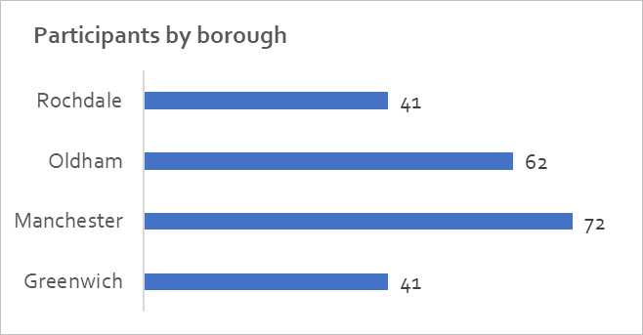

Care leavers
A quarter (55) of the participants had previously been in care. Greenwich borough had the highest proportion of participants who had been in care (13 out of 41).
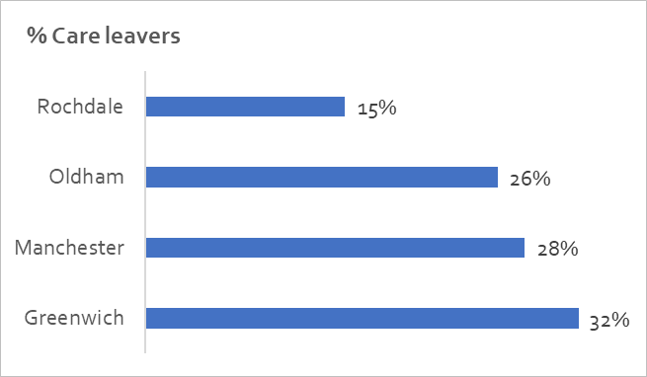
As we will see below, care leavers presented to the support team with high needs. There was also a group of care leavers who did not engage with the service sufficiently for workers to assess their needs, this group is also likely to have high needs. The project recognised that supporting young care leavers required more patience, more persistence, and had a higher cost, than other homeless young people.
Care leavers were found to take longer to engage with the support team as they were more likely to be less trusting of new professionals, having had to work with agencies for much of their lives.
Care leavers took longer to engage with education or training courses. This may have been due to their educational abilities - workers saw several care leavers who were school refusers or who left school with low grades.
“[Client] is a care leaver and joined the programme soon after he turned 18. He had been in and out of custody since his 15th birthday and felt there was very little he could do or achieve. [Client] was a school refuser and struggled with classroom settings. His relationship with family was fraught and he was unable to visit the family home due to violence towards his step-father. [Client] was referred to Your Chance on his release from custody.” [Board report case study]

Those with an offending background at the start of the project
35% (76) of the participants had an offending background (i.e. had been convicted, or who had a pending conviction) at the start of the project. Greenwich borough had the highest proportion of participants who had an offending background (19 out of 41).
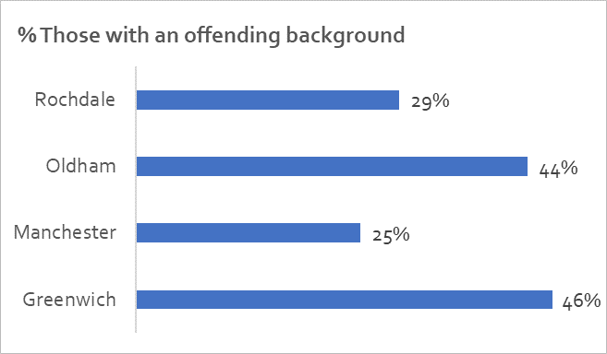

Those who had a mental health diagnosis at the start or during the project
42% (90) had a mental health diagnosis made prior to or during their time on the Your Chance project. These were mostly for depression as well as (and in combination with) other conditions such as bipolar disorder, personality disorder, schizophrenia and PTSD. Greenwich borough also had the highest proportion of participants who had a mental health diagnosis (20 out of 41).
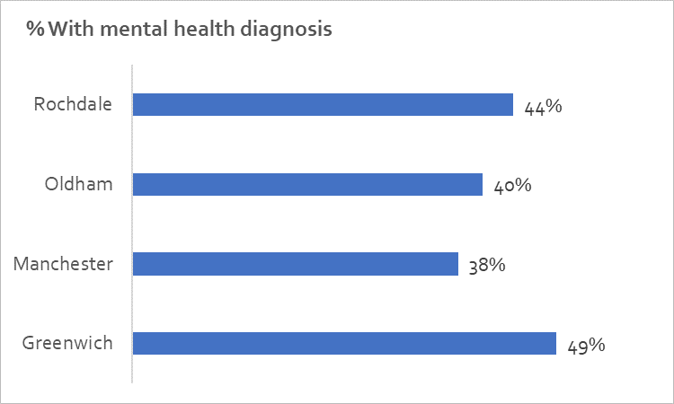

Older (22+) and younger (18-21) participants.
Three quarters of participants were aged 18-21 when they started the Your Chance project. Greenwich had the highest proportion of younger participants (83%) and Manchester had the highest proportion of older participants (32%).
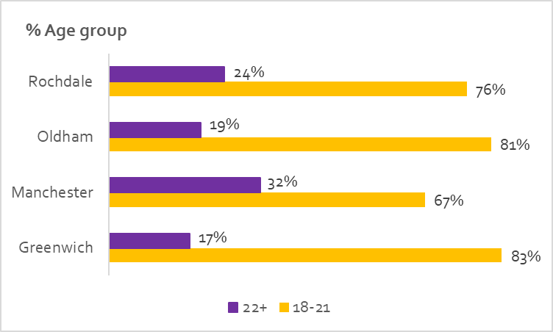
The proportion of individuals aged 18-19 on the programme (42%) was slightly higher than anticipated. Some referrers identified people when they were 17 to enable them to join the programme as soon as they became eligible.

Male and female participants
There were over twice as many male participants (68%) as female (32%). In Oldham there were over three times as many males (77%) as females (23%).
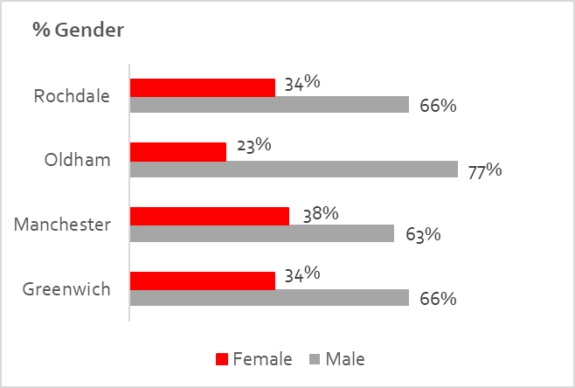

Needs identified at the first risk assessment
The more complex needs a client has, the more support is likely to be required for them to achieve the desired outcomes. These young people might also have required multi-agency support and engagement with different support workers.
Support workers undertook risk assessments with young people at an early stage of their support. If a young person was experiencing a crisis at the start of the project, this assessment may have been postponed until that had been resolved. This is likely to have decreased the risk scores compared with if the assessment had been done immediately. However, due to the issues relating to the Outcome Star mentioned above the support worker’s risk assessment is considered to have been the most accurate recording of client need.
The evaluation focusses on six priority risks:
- The participant’s mental health
- Criminal activity by the participant
- The participant’s safeguarding/harassment risk (from others)
- Violence by the participant to others
- Use of drugs and alcohol
- Money management
Looking at participants as whole, mental health, drugs and alcohol and money managements were the most prevalent risks (i.e. over four out of ten participants were recorded as having a “High” or “Medium” risk in these priority areas).

Risk | % High or Medium
Mental health | 45%
Criminal activity | 26%
Safeguarding/Harassment (from others) | 33%
Violence to others | 26%
Drugs/Alcohol | 44%
Money management | 44%
When looking at the priority groups (see table below) it becomes apparent that some risks are more prevalent than other in different groups.
- Oldham had higher proportions of participants presenting with five of the six risks than the other three boroughs. In every risk area the proportion presenting with high or medium risk was higher in Rochdale than the average for the cohort as a whole.
- The level of risk between younger and older participants was broadly similar, except for safeguarding and harassment from others, with 36% of younger participants being at high or medium risk compared with 26% of older ones.
- Across every risk area, care leavers were more likely to be at high or medium levels of risk than those who had not been in care – the proportion of those at risk of safeguarding and harassment from others (46%) and violence to others (39%) being particularly high.
- Those with a mental health diagnosis were also significantly more at risk of violence to others (35%) than those without a diagnosis (19%).
- The proportion of those with an offending background at high or medium risk was often much higher than those without an offending background and the average. For example, 62% were are at high or medium risk of alcohol compared with 38% of those without an offending background, and 43% were are at high or medium risk of violence to others compared with 18% of those without an offending background.
- The level of risk between males and females was broadly similar, except from criminal activity (34% male and 11% female). A greater proportion of males were at risk in every area except for safeguarding and harassment from others, with 39% of female participants being at high or medium risk compared with 30% of males.
When considering multiple risks/needs, on average 4 out of 10 participants were at high or medium risk in 3 or more of the priority risk areas listed above.
- In Oldham and Rochdale, over half (53%) of participants were at high or medium risk in 3 or more of the priority risk areas.
- Multiple risks/needs were prevalent amongst those with an offending background (53% at high or medium risk in 3 or more of the priority risk areas) and care leavers (49%).

 | % with “High” or “Medium risk at first risk assessment |  |  |  |  |  | % with 3+ risk areas “High” or “Medium”
Group (number in group) | Mental health | Criminal activity | Safeguarding/  Harassment | Violence  to others | Drugs/  Alcohol | Money management
All (168) | 45% | 26% | 33% | 26% | 44% | 44% | 40%
Greenwich (40) | 35% | 23% | 33% | 30% | 45% | 28% | 35%
Manchester (49) | 29% | 18% | 12% | 14% | 39% | 31% | 22|%
Oldham (45) | 67% | 36% | 49% | 33% | 44% | 71% | 53%
Rochdale (34) | 53% | 29% | 44% | 29% | 50% | 47% | 53%
Younger 18-21 (125) | 47% | 26% | 36% | 27% | 43% | 45% | 41%
Older 22+ (42) | 40% | 24% | 26% | 24% | 48% | 33% | 38%
Care leavers (41) | 46% | 27% | 46% | 39% | 49% | 51% | 49%
Not care leavers (124) | 44% | 25% | 29% | 21% | 41% | 44% | 36%
Mental health diagnosis (77) | 65% | 30% | 36% | 35% | 47% | 42% | 44%
No mental health diagnosis (85) | 31% | 25% | 31% | 19% | 45% | 46% | 38%
Offending background (53) | 51% | 43% | 40% | 43% | 62% | 43% | 53%
No offending background (104) | 46% | 20% | 32% | 18% | 38% | 46% | 37%
Male (112) | 46% | 34% | 30% | 29% | 45% | 46% | 43%
Female (56) | 45% | 11% | 39% | 20% | 43% | 39% | 34%

Situation on referral
Some young people interviewed described the difficult situation they were in before being supported by Your Chance.
“I was on the streets for two months. I tried to commit suicide - I thought I was going to be homeless forever” [C2]
“I was an alcoholic, I was rank, I had no family, I was hanging around with the wrong people - I had nothing in my life going for me at all, until I met [Support Worker]” [C3]
A third of participants were referred to Your Chance because of family relationship breakdown or parental eviction. Eviction (21%) and risk of eviction (18%) were also common reasons.
Reasons for referral (216 participants) | %
Family relationship breakdown/parental eviction | 34%
Evicted from previous accommodation | 21%
Support needs (offending, mental health) | 20%
Risk of eviction | 18%
Relocation due to risk assessment | 5%
Sofa surfing | 2%
In unsuitable accommodation | 0.5%

In terms of what accommodation participants were staying in on referral, two thirds of participants were either in supported housing (35%) or staying with family or friends (31%). 14 people (6%) were rough sleeping.
Accommodation on referral (216 participants) | %
Supported housing | 35%
Family or friends | 31%
General needs tenancy | 10%
Other | 6%
Prison | 6%
Rough sleeping | 6%
Not known, private sector tenancy, sofa surfing, Children’s home/foster care | 1% (each)
B&B | 0.5%
- Overview of outcomes achieved

Outcomes achieved and financial performance
In summary the actual number of outcomes achieved by the Your Chance project are in the table below. By supporting more people than planned, the project was able to exceed the targets for overall number of outcomes achieved and the value generated by those outcomes. The actual outcome value generated was £9,105 above the contract “cap” so £1,654,340 was generated by the project.
 | Base case  (Jan 15) | Target  (May 16) | Actual
Number of young people supported | 178 | 216 | 216
Outcomes achieved per participant | 8.4 | 7.3 | 7.7
Overall number of outcomes | 1,474 | 1,583 | 1,667
Outcome value generated | £1,555,610 | £1,573,375 | £1,663,445
% value contributed by assessments | 12% | 14% | 13%
% value contributed by accommodation | 58% | 64% | 66%
% value contributed by education and training | 11% | 7% | 7%
% value contributed by employment and volunteering | 19% | 15% | 14%

Outcomes achieved per participant
On average each participant achieved 7.7 outcomes across the four aspects of the project (assessment, accommodation, education and training, and employment and volunteering).
Those participants in Greenwich achieved 9.3 outcomes each even though their cohort was over represented in most of the priority groups (care leavers, offending background and mental health diagnosis). Participants in Oldham also achieved more outcomes (8.2) than the average (7.7) despite having the cohort with the greatest proportion of participants at high and medium risk in the priority risk areas.
Perhaps unsurprisingly care leavers and offenders did not achieve, on average as many outcomes as their counterparts who did not have that background but, interestingly, having a mental health diagnosis does not seem to have been a barrier to achieving outcomes as those who did have a diagnosis achieved, on average, 8.2 outcomes each compared with 7.7 for those who did not.

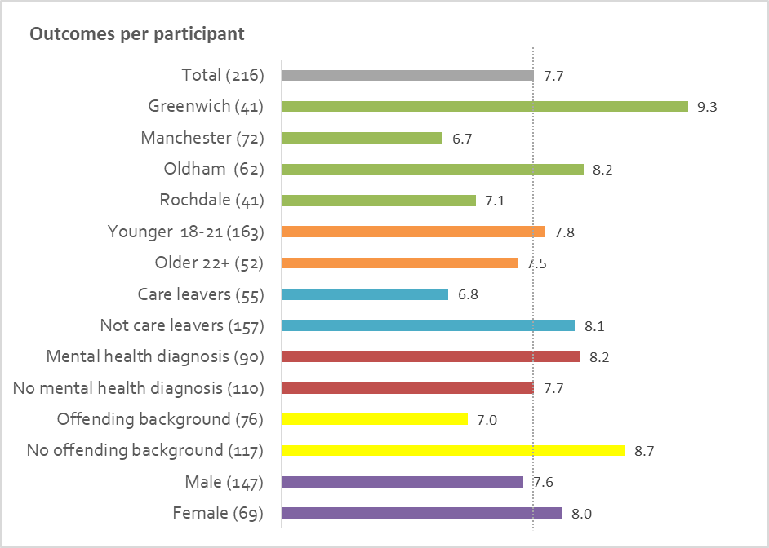

- Accommodation outcomes

Outcome criteria and evidence required
The “Move into Accommodation” outcome was achieved by the participant moving into secure accommodation (see footnote 6, page 7). This outcome could only be achieved once. If an individual abandoned secure accommodation before achieving the 3-month sustainment period, then any subsequent accommodation needed to achieve an additional 3 months sustainment before being eligible to claim the 3 month sustainment accommodation outcome.
Sustainment of accommodation outcomes were achieved by the individual sustaining stable accommodation for 3, 6, 12, and 18 months from their Move into Accommodation start date. As above, each outcome could only be achieved once; even where accommodation is abandoned.
If participants moved from one stable accommodation option to another, the arrangement was treated as continuous (i.e. the period of sustainment was combined), providing the moves were planned (i.e. not eviction, abandonment or imprisonment).
When participants moved between stable accommodations, but there was a gap between the end of one arrangement and the start of another, then the gap was acceptable provided that it was no longer than two weeks and could be verified, otherwise the period of sustainment was “reset” from the time the participant moved back into stable accommodation.
The evidence necessary to claim accommodation outcomes included:
- For independent accommodation: a signed copy of a tenancy agreement (including address)
- For living with friends or family: signed confirmation of exclusive occupation from the friend or family member, together with the address, or, where this cannot be obtained, a signed declaration by both the young person and the provider, stating that this is the case.
- For a hostel (not rough sleepers’ hostels/direct access) and supported housing: a licence or tenancy agreement.

Accommodation outcomes achieved
In total the project evidenced 192 Move into Accommodation outcomes against a revised target of 191. This represents 89% of clients (against a revised target of 88%).
Due to DCLG stipulations the project was not able to claim the Move into Accommodation outcome for six young people on notice to leave supported accommodation at the point of referral (although they subsequently achieved sustainment outcomes).
Sustainment of accommodation outcomes were achieved by the individual sustaining stable accommodation for 3, 6, 12, and 18 months. Each outcome could only be achieved once per client. Your Chance exceeded its target in every one of these outcomes.

Outcome | Outcomes achieved |  | Revised target
 | Q | % | Q | %
Move into Accommodation | 192 | 89% | 191 | 88%
3 months sustained | 188 | 87% | 171 | 79%
6 months sustained | 179 | 83% | 156 | 72%
12 months sustained | 162 | 75% | 150 | 69%
18 months sustained | 142 | 66% | 130 | 60%

In terms of sustainment “conversion”
- 95% of those who achieved the 3-month sustainment outcome went on to achieve the 6-month outcome.
- 91% of those who achieved the 6-month sustainment outcome went on to achieve the 12-month outcome.
- 88% of those who achieved the 12-month sustainment outcome went on to achieve the 18-month outcome.

12 month sustained accommodation outcomes by priority segment
Greenwich and Oldham fared particularly well with this outcome, with either 8 or 9 out of 10 participants supported achieving this level of stable accommodation. Manchester (63%) was quite far below the project average (75%).
For other priority groups there were big differences in achieving this outcome between care leavers (67%) and non-care leavers (78%) and between males (71%) and females (83%).
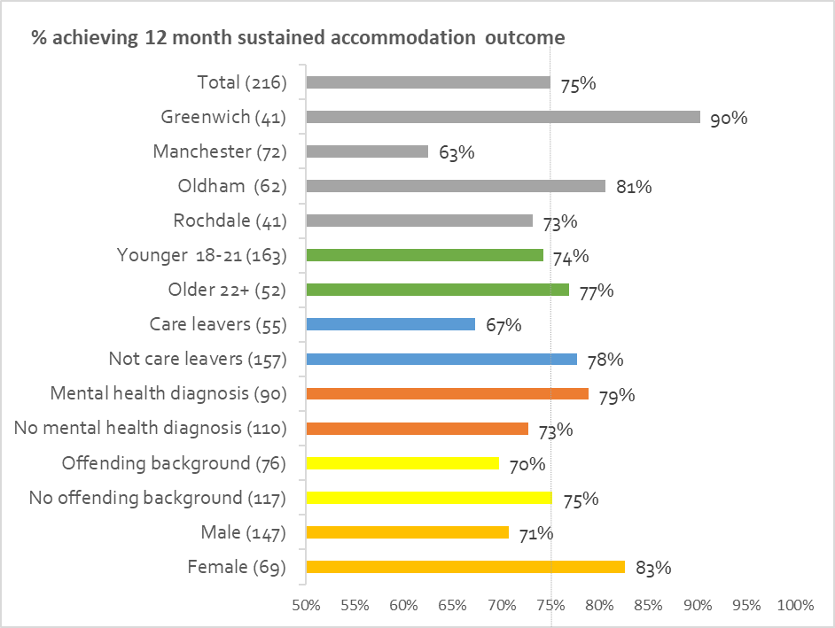

Reasons for not achieving accommodation outcomes
The majority of the 24 clients without a Move into Accommodation dropped out of the programme and the worker was not able to contact them about their situation. 16 of these people did not achieve any other accommodation, education or employment outcomes during the project.
Reasons for not sustaining accommodation included:
- Disengagement because of chaotic lifestyles – in these cases support workers attempted to keep track of the young person through other agencies. For example, the project was able to continue to claim accommodation outcomes for some participants after they disengaged as other agencies could confirm where they were living.
- Moving away from the area – support workers would still try to keep in touch in case they returned.
- Disengagement as a reaction to leaving custody. The project noted that a combination of offending with another need reduced the likelihood of a client achieving an accommodation outcome. To mitigate against this, support workers tried to build the strongest possible relationship with the young person before they were released, for example by visiting them whilst in custody or meeting them from the gate on release.
- The client wasn’t ready for the type of accommodation – support workers strove to ensure that young people were able to manage in the accommodation they were placed in, however some couldn’t cope and needed to return to more supported environments.

Factors influencing the achievement of accommodation outcomes

The accommodation available in the borough
There were differences in the availability of different types of accommodation across the four boroughs.
- Rochdale could access more social housing (which was rare in the other three areas) but not a lot of supported accommodation.
- In Oldham there was a balance of social and supported accommodation.
- Most young people referred to Your Chance in Greenwich were not eligible for supported accommodation, having already exhausted these options. Greenwich also had less social housing, therefore placements needed to be found from within the private rented sector.
- Manchester had more supported accommodation available, with some social housing. Throughout the project it proved to be the most difficult area to source suitable accommodation. This may be reflected in the low sustainment figure above (See 8.3)
The table below compares accommodation type on referral with the last known accommodation type of the participant. What can be seen is that Greenwich, Oldham and Rochdale were able to move participants away from Supported Housing (in Greenwich mainly to the private sector, in Oldham and Rochdale mainly to General Needs Tenancies). However, the proportion of participants in Supported Housing increased in Manchester. Only 74% of participants whose last accommodation type was Supported Housing had achieved the 12-month sustainment outcome compared with 96% for PRS, 95% for General Needs Tenancies and 88% for Family or Friends.
Borough | Most common (over 20%) accommodations at the start of Your Chance | Most common (over 20%) accommodations at the end of Your Chance
Greenwich | Supported Housing (22, 54%)  Family or Friends (16, 39%) | Private rented sector (17, 47%)  Family or Friends (10, 28%)
Manchester | Supported Housing (19, 26%)  Family or Friends (17, 24%) | Family or Friends (21, 35%)  Supported Housing (17, 28%)  General Needs Tenancy (16, 27%)
Oldham | Family and Friends (21, 34%)  Supported Housing (19, 31%) | General Needs Tenancy (22, 39%)  Family or Friends (18, 32%)
Rochdale | Supported Housing (15, 37%)  Family or Friends (12, 29%) | General Needs Tenancy (14, 41%)  Family or Friends (12, 35%)
Moving back with family and friends was a common route for young people. In each case Support Workers would consider whether such a move was the best option for the young person. Sometimes clients moved from supported accommodation back to their families. This was usually a positive move and related to either a young person facing the harsh reality of living on their own and deciding that home is better, or both the family and the young person having a break from each other - allowing relationships to be rebuilt.
In these cases, support workers or Depaul’s dedicated mediation worker (in Oldham only) supporting clients in the North West provided mediation support to help sustain this accommodation (see 4.4 above). The project found that mediation worked best as a preventative strategy or with those recently homeless. It was less relevant for those who had been homeless some time and who had burnt their bridges with family and other services.
A spell in supported accommodation, which most clients had, was needed to help them get to a point of stability. Some then progressed through different levels of supported accommodation, at a pace they could cope with, to become more independent and learn the skills required to live alone and manage a tenancy. The first accommodation may have provided 24-hour support, the second just between 9am and 5pm and the third only visiting support. This is referenced later as a “staircase” approach (see 14.1).
Placing a young person in supported accommodation provided the support worker with benefits in terms of engagement and freeing up resources that would have been spent tracking them down. However, due to the limited time clients could stay in supported accommodation, support workers needed to focus on moving those young people on to other types of accommodation that may have been more challenging to secure such as social housing or the private rented sector (PRS) in order to achieve other outcomes.
Social housing was often young people’s preferred accommodation option. One support worker quoted in a board report said “young people from Oldham were not keen on entering PRS accommodation. They expected to be placed in social housing as this is where their families lived.” However, waiting lists could extend to over a year, longer in more popular areas.
Those wanting to bid for social housing are placed in priority “bands” which differ between local authorities (“A” being the highest priority and generally only assigned to those in emergency need). In Manchester 75% of successful bids were from young people in band “B”.
The bidding system acted as a disincentive for young people to move into PRS accommodation as that automatically put them in a lower priority band – D (whereas being in supported accommodation kept them in band B). However, it may also have provided an incentive for young people to complete some education outcomes as, in Manchester, completing a tenancy training course qualified a young person to be in band B.
Where social housing wasn’t available, or when supported accommodation wasn’t appropriate for the young person, placing young people was more challenging and workers had to explore options in the private rented sector. In most cases, however, PRS was an expensive and unattainable option and young people were reluctant to enter the private market (possibly due to its effect on their ability to successfully bid for social housing) even if the project offered to cover their rent deposits (see 4.4 above).

When a young person started with Your Chance
Young people who started between October and December 2015 (“cohort 4”) appear to have had a lower accommodation success rate across all but one outcome than others, even those recruited in the previous quarter.
In October 2017 only 81% if the 56 people in cohort 4 had achieved the Move into Accommodation outcome compared with 98% of the 59 people in cohort 3 (who started July-September 2015).
This may be because when that cohort started caseloads were already high, and so it is likely that the time spent on those starters was lower in comparison to other young people on the programme. It was also noted above (see 5.1) that young people referred near the end of the referring window (December 2015) may have been less suitable for the project.

Building relationships with housing teams and accommodation providers
The Your Chance team made sure they developed positive relationships with providers and housing teams.
“Because we would go with clients for their assessments for supported accommodation. We made their [the housing team’s] life easier. They would organise the interview and we made it happen. It was a world class partnership.” [SWG]
These relationships often resulted in an increased supply of accommodation options, or changes in approach that facilitated sustainment.
- In Manchester and Rochdale, housing associations that had banned under 35-year olds accessing one-bedroom flats if they had historical anti-social behaviour problems agreed to consider applications from Your Chance clients if the young person was doing something meaningful with their time and they were able to contact the support worker if any issues arose.
- In Manchester relationships with offender workers and probation staff opened links to PRS landlords to discuss placing clients.
- In Oldham, links were built with the Council’s PRS liaison team and support workers were able to access their list of responsible landlords.
- In Rochdale good links were made with Rochdale Boroughwide Housing (the largest social housing provider) who were very pleased with the way Your Chance worked to manage and sustain the tenancies of young people placed in their properties.
- In Greenwich good relationships were built with PRS landlords. This was primarily achieved through links with agencies as the project found some individual landlords to be unscrupulous. Despite having to pay agency fees, by dealing with a few, select companies who understood the young people’s needs, the project was offered better quality accommodation with more understanding landlords. This was a major achievement for the project.
- Often the cost of rent in supported accommodation is so high that young people cannot get a job as they would no longer be eligible for Housing Benefit and so unable to pay their current rent, or a deposit on their new tenancy. The programme manager advocated with the Department of Work and Pensions so that young people in supported accommodation in Manchester who were working could claim a discretionary housing payment for 6 months to cover their rent for this period, allowing them to save for a deposit and have stability at work without having to move quickly. In this time, workers could help young people find a suitable place to live in a more planned way.

The impact of changes to housing benefit
From April 2017 the entitlement to the housing element of Universal Credit (or Housing Benefit) was removed from young people aged 18 to 21. Although several of the Your Chance clients may have been covered by exemptions to this change, it may have caused some housing providers to be even more wary about taking on new young people as tenants if they were no longer going to receive housing benefit.
In Manchester the project had high hopes for a partnership with the Council’s brokerage scheme which links 18-35 year olds with PRS landlords. However, it proved challenging to get this relationship off the ground possibly due to their landlords’ concerns about whether they could guarantee their rent. In the end the Your Chance team found it more effective to make their own connections with landlords through letting agencies.

The effort of support workers
Young people interviewed commented on the importance of the help they received from support workers in finding and sustaining accommodation.
“The place I’m in now is the longest tenancy I’ve even had – I’ve been there over a year and that’s because [Support worker] was assisting me, she was so helpful.” [C3]
“Within 10 minutes my support worker came down and put me in a hostel. I was there a year and then supported accommodation for a year. [Support worker] came to view the property with me.” [C12]
“I learnt all the real-life things that you do have to do, like paying bills, credit cards, but aren’t taught anywhere. That helped me so much.” [C1]

- Education and training outcomes

Outcome criteria and evidence required
To qualify for an outcome, all qualifications needed to be accredited and have a Qualification Accreditation Number (QAN)
- For the Entry into Education outcome a payment was made when a client had had an individual skills assessment from an education or training provider, a learning agreement has been put in place, and the individual had been registered onto a course and attended an initial session.
- The First Entry-level qualification outcome could only be claimed when the client had no existing qualifications. To qualify, the client needed to have an individual skills assessment from an education or training provider on enrolling on a course, have completed an accredited entry level course, and achieved the relevant qualification. The entry level course needed to involve at least 45 Guided Learning Hours (GLH) and include either Mathematics or English.
- The Level 1 qualification outcome required the client to complete a Level 1 qualification (or a combination of Level 1 qualifications) which involved at least 120 GLH. This could be an NVQ Level 1, a GCSE or an equivalent Level 1 qualification. If the client did not have a Mathematics or English Qualification, this outcome claim had to include a qualification in one of these subjects. This outcome also included Level 2 qualifications that did not meet the 325 GLH required to claim the full Level 2 Outcome below.
- The Level 2 qualification outcome required the client to complete a full Level 2 qualification, involving at least 325 GLH. This was the equivalent of a full NVQ Level 2 or 5 GCSEs at grades A*-C. Where the client did not have existing Mathematics and English qualifications at a minimum of Level 1, then the Level 2 Outcome claim had to include Mathematics and English. Clients on Level 3 courses were eligible for Level 2 outcomes.
Evidence required to claim education and training outcomes included:
- For entry into education: a signed and headed letter from the education or training provider certifying enrolment and first session attendance.
- For first level entry, Level 1 and 2 qualifications: the qualification certificate or a signed headed letter from the education or training provider.

Education and training outcomes achieved
The project evidenced 91 Entry into Education or Training outcomes against a revised target of 101. This represents 42% of clients (against a revised target of 47%). The project over-achieved slightly on the first entry-level qualification outcome.
Tenancy training and employability skills courses were most likely to be completed successfully.

Outcome | Outcomes achieved |  | Revised target
 | Q | % | Q | %
Entry into Education | 91 | 42% | 101 | 47%
First Entry-level qualification | 25 | 12% | 16 | 7%
Level 1 qualification | 11 | 5% | 13 | 5%
Level 2 qualification | 1 | 0% | 5 | 2%

Reasons for not achieving education and training outcomes
It was challenging to achieve education outcomes as very few young people wanted to start education preferring to pursue employment or apprenticeships directly (however this also provided the project the opportunity to over-deliver on employment outcomes).
In addition, the criteria required by DCLG to qualify for an education and training outcome did not always resonate with young people’s level of need or ambition.
The majority of courses clients wanted to enrol in were more vocational such as those that supported them to better manage their own accommodation or develop their understanding of what areas of work may be of interest. These included short courses (e.g. tenancy training, life skills or employability) that either were unaccredited or did not meet the required GLH. Despite this, these courses were considered to be highly valuable experiences for the clients and likely to improve their prospects of progressing towards further education or employment.
The proportion of outcomes achieved against education outcomes was lower than forecast. However, it was noted that given the risk and need of the cohort, education at the level required to achieve outcomes was often not feasible for clients.

Education and training outcomes by priority segment
Greenwich’s success with this outcome can be explained by a local authority requirement that young people attend money management training. As noted above, being a care leaver and/or previously offending is associated with a lower proportion of positive outcomes than those who did not have that background. However, having a mental health diagnosis does not seem to have impeded participants from achieving educational outcomes.
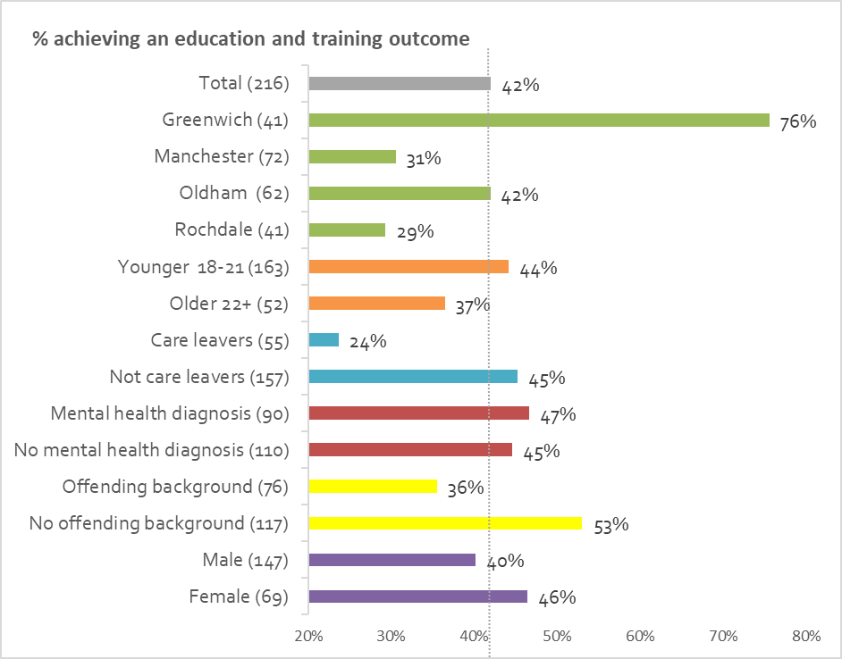

Factors influencing the achievement of education and training outcomes

Offering accredited training
The project worked closely with agencies in Manchester and Greenwich who offered accredited tenancy training courses. As well as benefiting clients by moving them up housing waiting lists, providing this also helped to achieve the Entry into Education outcome.

Local authority requirements
Entry into Education outcomes were higher in Greenwich. This was probably explained by the local authority insisting that all young people attend their ‘money-house’ training before being considered for supported or other accommodation in the Borough.

Meeting a preference for shorter courses
Many clients’ level of need was too high to consider year-long courses, and they preferred shorter courses. However, in some cases short courses still met the requirements for the Level 1 outcome: For example, the Prince’s Trust “Team” Programme - a 12-week course which results in a Level 1 Certificate in Employment, Teamwork and Community Skills. This course was particularly accessible for the three North West boroughs.

Accommodation outcome achieved
The longer the accommodation sustainment the more likely educational outcomes would be achieved. Those who sustained accommodation for 18 months achieved 0.8 educational outcomes per participant double that of those that only achieved 6 or 12 months sustainment. None of the ten people who only achieved 3 months accommodation sustainment achieved any educational outcomes.
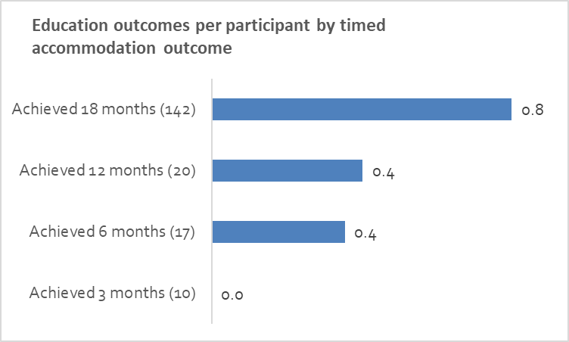

Use of mentors
In the last year of the programme young people had access to mentors who were able to support them to sustain their training or education, and who could also provide additional low-level support where needed.

- Employment and volunteering outcomes

Outcome criteria and evidence required
For the project to claim volunteering outcomes a client needed to carry out an average of at least 6 hours voluntary work a week for 6, 13, 20 and 26 weeks.
To claim the Entry into Employment outcome a client needed to accept an offer of employment and attend on at least the first day of work.
If a client completed 13 and then 26 weeks of work (a minimum of 16 hours a week full time and 8-16 hours a week part time) then employment sustainment outcomes could be claimed. It was also possible to claim the sustainment outcomes for periods of self-employment. The weeks of work (or volunteering) could be cumulative - allowing for gaps in between jobs.
It was possible to claim outcomes for a client who moved from voluntary work to part time work to full time work. However, once both the 13 weeks and 26 weeks full time employment outcomes had been claimed, it was not possible to claim any further employment or volunteering outcomes.
Evidence required to claim employment and volunteering outcomes included:
- For volunteering: a signed letter from organisation confirming volunteering agreement
- For entry into employment: a signed letter from employer on headed paper, a copy of the individual’s first pay slip, or a copy of the employment contract
- For sustainment outcomes: a signed letter from employer on headed paper, or copies of all relevant pay slips
- For first level entry, Level 1 and 2 qualifications: the qualification certificate or a signed headed letter from the education or training provider.

Employment and volunteering outcomes achieved
The project over-achieved on volunteering outcomes, employment outcomes were slightly lower than target, with the exception of 26 weeks full-time employment.

Outcome | Outcomes achieved |  | Revised target
 | Q | % | Q | %
6 weeks volunteering | 16 | 7% | 13 | 6%
13 weeks volunteering | 13 | 6% | 11 | 5%
20 weeks volunteering | 11 | 5% | 6 | 3%
26 weeks volunteering | 10 | 5% | 6 | 3%
Entry into employment | 57 | 26% | 61 | 28%
13 weeks part-time employment | 2 | 1% | 3 | 1%
26 weeks part-time employment | 0 | 0 | 2 | 1%
13 weeks full-time employment | 30 | 13% | 33 | 15%
26 weeks full-time employment | 20 | 9% | 16 | 7%

In March 2017 analysis revealed types of jobs most often taken by Your Chance clients. Construction/labouring was the most popular (15 jobs at the time), followed by Shop Assistant (12), Cleaner (10), Warehouse (9), Business and Admin (8) and Chef (8). The placements most likely to be sustained over 26 weeks were in construction, labourer and cleaner roles.

Reasons for not achieving employment and volunteering outcomes
Not many young people took on part time work so during the project outcomes for 13 and 26-week part time employment were reduced from 9% and 6% of clients to 1% each.
For clients living in Oldham or Rochdale, the most likely place where they could get employment was in Manchester and the cost of travel alone was found to be a barrier. In many cases, it was a struggle to help clients see the advantage of transitioning off benefits and into work.
When clients did participate in volunteering they may not always have met the required number of hours and it was challenging for the support workers to obtain the required evidence.

Employment and volunteering outcomes by priority segment
As noted above, care leavers and those with an offending background achieve outcomes at a lower rate than most other groups. In addition, men were more likely to find employment (30%) than women (19%).
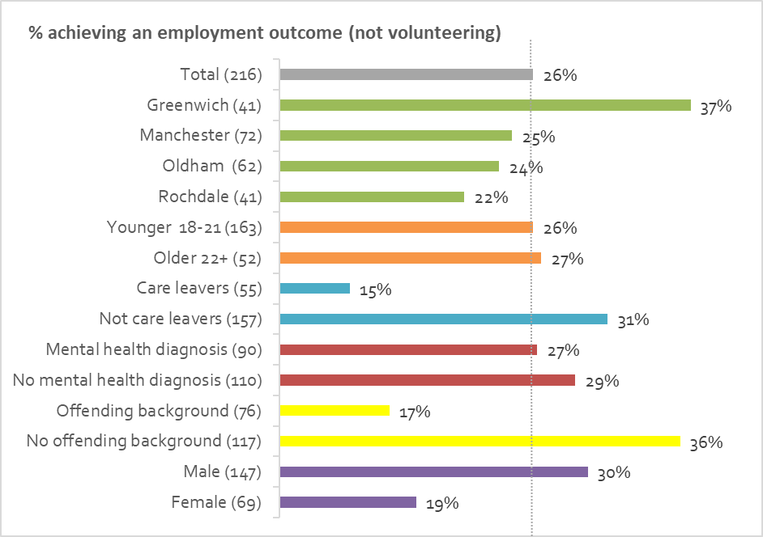

Factors influencing the achievement of employment and volunteering outcomes

The availability and accessibility of opportunities
Job opportunities were more widely available in Greenwich where support workers referred young people to Greenwich Local Labour and Business (GLLAB) who dealt with all the employment opportunities in the area.
“There was a typical north/south divide with more jobs in Greenwich such as construction related roles. There was more housing availability in the north, however, without jobs, young people couldn’t afford or sustain these.” [Support worker quoted in Board Report]

Recruiting dedicated, specialist employment staff
In October 2015 the project recruited a part time (three days a week) Employability Worker, based in the North West, to ensure the project had capacity to build relationships with local businesses, create work placement opportunities for young people, and support employers with clients they took on.
Support Workers would refer young people who were job ready, the Employability Worker would then meet with the client to identify and progress opportunities whilst liaising with employers and support workers. Young people understood that the Employability Worker was focussed on employment and to save other support needs for discussion with their support workers. Support workers reported that this approach (which was similar to the Greenwich team referring to GLLAB) helped focus the minds of young people on available employment, training and volunteering opportunities.
Relationships with employers can take time to build, but the Employability Worker successfully negotiated a relationship with B&M stores in Manchester who offered work placements for clients.
The impact of this role may have been reflected in the progress of cohort 4 (young people who started between October and December 2015). Despite this cohort performing worse on assessment, accommodation and education outcomes they were faster at entering employment. This may have been due to the fact they were the first cohort who could access support from the Employability Worker from the start of their time with Your Chance.
In March 2016 this role was increased to a full time Employment and Partnerships Coordinator (EPC) post (which was filled by a different person). This role focussed on building relationships with employers who are willing to offer opportunities to young people and was supported by a part time EETV Worker (from April 2016). Employers involved with Your Chance clients as a result of the EPC’s work included the NHS, M&S, Amazon, and Manchester United FC.
There was an overwhelming feedback from support workers that having these posts led to increased outcomes.

Accommodation status
As with educational outcomes above, the longer accommodation is sustained the more likely employment and volunteering outcomes will be achieved.
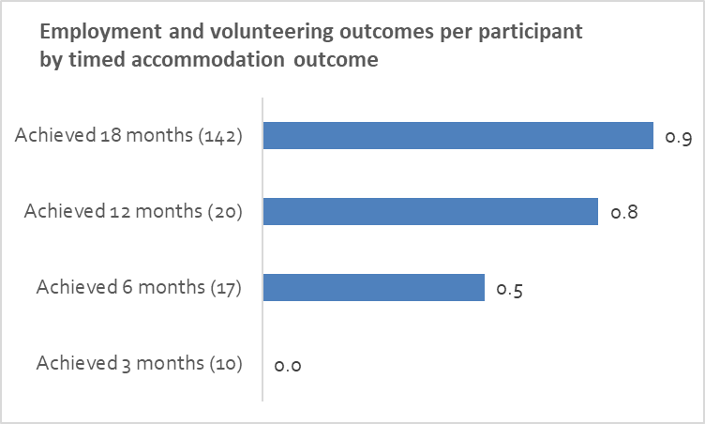

Introducing employers and volunteering agencies to clients
The team organised visits to colleges, employers, and job fairs. One such event at Manchester University was attended by ten young people and included a tour of the facilities and a discussion with the apprenticeship team and offers of placements.
The week-long, work ready programme also brought employers, training providers and clients together. Employers such as Pret A Manger, Timpson’s, Manchester City Football Club, Manchester University and B&M group attended offering work placements, training and possible job opportunities. Timpson’s, for example, offered to meet any young person regardless of qualification history who was interested in working and give them a two-week placement. If they did well they would be offered a 16-week paid training with a high chance of a job at the end.
As well as meeting these employers, young people could also receive training (barista training, first aid and food hygiene) and attend sessions on building confidence and self-esteem, mindfulness and CV writing.
The team also arranged for volunteer agencies in Oldham, Rochdale and Manchester (Voluntary Action Oldham / Rochdale, ‘Do It!’ Manchester) to meet with some interested young people.

Providing targeted, intensive support
The EPC proactively identified clients who might benefit from additional one to one support to get them ready for work. These were mainly young people who have been actively engaged with the programme and expressed a desire to work but who, when offered appropriate opportunities, did not take them up. This intervention included:
- One to one self-esteem workshops
- One to one interview and job preparation sessions
- Visits to employers prior to starting a job
- Accompanying young people to EETV opportunities and working alongside them for the day
- Liaising with family to include them in trying to encourage the young person to engage with EETV opportunities
- Liaising with the housing provider (family or supported accommodation) to encourage the young person to prepare for their first day
- Buddying with another young person who is also starting a new opportunity.
Of the 17 young people identified, 10 realised their EETV goals thanks to this intensive support, however 7 did not engage with the initiative.

Use of mentors
When young people were job ready they had access to Depaul volunteer mentors who specialised in supporting young people to sustain EETV opportunities. The mentors provided extra support and motivation to the young person and took some of the workload burden off the support worker

Getting support at home
Sustained employment outcomes were higher for young people who were living with family and friends, or who were in a general needs tenancy. Young people in these situations may have benefitted from extra support from family, friends or the housing association. In addition, rents are usually lower within the family home or general needs accommodation, making it easier for young people to commit to starting a work placement and stay in work.
- Additional project outcomes for clients
As a PBR project, Your Chance focussed its resources on achieving the accommodation, education and employment outcomes above – however the holistic approach used to achieve those outcomes also generated additional outcomes for young people.
Throughout the three years the project collected a large amount of data on participants and their achievement of the PBR outcomes. Understandably, less data was collected on “softer” outcomes. As the Outcome Star was found not to be very useful in measuring these outcomes (see 5.4 above), our findings in this section draw from qualitative interviews, client feedback included in board reports, changes in support workers’ assessment of client risk, and an exit survey that 33 clients participated in.

Offending rates
Of the 76 participants who had an offending background before Your Chance, 39 (51%) were convicted of an offence during their time on the Your Chance project. 11 of the 117 that did not have an offending background (9%) also committed an offence.

Improved mental wellbeing
Participants were asked in an exit survey to compare how they felt at the end of Your Chance compared with when their support started.
- 74% (of 31) strongly agreed they felt “more confident in my abilities”
- 70% (30) strongly agreed they felt “more optimistic about the future”
- 65% (31) strongly agreed they felt “less stressed and/or anxious”
- 65% (31) strongly agreed they “like myself more”
In each case no-one disagreed with these statements.
In qualitative feedback clients mentioned how their mental wellbeing had improved. This was mentioned in all the interviews completed.
“CBT gave me time and space to think through all the stuff going on in my head. It helped that I could see my therapist on my own terms as I could never keep a booked appointment, no matter how hard people tried to get me to them.” [Client quote from board report]
“There were times I used to get so depressed, being indoors by myself. [Support worker] would say let’s go out, let’s have Costa, let’s talk about how I was and how I felt” – I felt I had support.” [C1]
“It mucked up my mental health not being settled, not having somewhere to live. I’m much happier now because I have my own place” [C2]
“Instead of staying in drinking and taking drugs, now I wake up, get showered, get dressed, get breakfast and think about a way to make my day better.” [C7]
“My mental health is better – I have more of a scheduled routine, I used to be all over the place. I feel less scatter-brained, less stressed. Running also clears my mind.” [C9]
“My state of mind was being morbid and upset. I am lot more happy minded.” [C10]

Increased resilience
It can be inferred that those clients who achieved the longer sustainment outcomes would have developed resilience to “stick with” their accommodation, education or employment. All the young people interviewed (12) commented that their ability to cope with challenging situations or disappointments had improved.
“I failed my course – before I would have left it, but now I sorted it out for myself and rebooked myself to do the exam again.” [C7]
“Mindfulness taught me how to breathe – not breathe to live, but breathe to survive and stay sane” [Client quote from board report]
It [Your Chance] makes you wake up and feel you can keep on going.” [C10]
It [Your Chance] made me become a good person – it made me realise you could do it, to think more positively and to know that things will take time.” [C11]
“I see things differently now, I’m more likely to think that if I focus on something I can do it” [C4]

Improved relationships and support networks
In interviews all young people mentioned how they had met new friends through the project, particularly through the running club formed in the North West. Others mentioned that their relationships with their families had improved (this may have been due to the project’s investment in mediation training).
“[Support worker] set up meeting my mum in a public place to speak to her because we weren’t getting along that much, our relationship is better now because of Your Chance.” [C9]
“I’m closer with my family now – they see I’m not the same person.” [C1]
“I have more friends now – they understand me, I’m getting along with my family. [Support worker] would stand up for me so they know what I need.” [C8]

Healthier lifestyles
The running club in the North West proved very popular with young people. Three young people ran in a Your Chance relay team in the Manchester marathon with two members of the support team. Five young people ran in the Your Chance Manchester 10k team.
“Running club gave me the confidence to meet new people and be brave enough to run around the streets getting sweaty and not worrying about looking cool; I love it” [Client quote from board report]
In interviews, some young people mentioned the support they had been given to give up or reduce their drinking or drug taking.
“I went to [service] to give up smoking and I’ve given up. I’m proud of myself” [C11]

Increased engagement in the community
Young people undertook several community fundraising activities to raise money for their trip to Bratislava, for example having a stall at Manchester’s Parklife festival.
Following the Mindful Art sessions held for clients, some young people displayed their art (some of which was for sale) at the opening night of an art exhibition in Manchester.
“I have more confidence, I would always be indoors but I’m socialising more and putting myself out there. I’ve done cleaning and portering jobs.” [C10]

- Additional project outcomes (Depaul)

Working on a PBR project
Despite some initial reservations, support workers became comfortable with the PBR approach.
“If they [PBR projects] are all run like this they will be great and young people will do really well” [Support worker quoted in a board report]
“I was nervous initially but can see the benefits now” [Support worker quoted in a board report]
Support workers interviewed said that the PBR nature of the project didn’t really make any difference to them and that they did not feel any pressure on targets. Some felt it had a significant positive influence on worker motivation and behaviour.
“We would have done what we did even if it wasn’t PBR. The outcome targets weren’t passed down to staff. They just focussed on what the project wanted to achieve.” [SW1]
“It didn’t influence me at all, I didn’t feel any pressure from management. I encouraged them to do things not because of the payment but because it was natural progress for them” [SW3]
“You knew it [the target] was there – there was lots of reporting, but people worked harder because they knew that. You were still driven to achieve good results – they were sensible results. It wasn’t about the targets themselves, it was more that you had an opportunity to achieve them.” [SWG]
“It’s a better way of working if you want to get the best out of staff – have a bit of competition, it had a motivating effect.” [SW2]
“People kept their motivation up – I wanted to make sure I got my numbers.” [SWG]
One important factor in staff’s perception of the PBR approach was Depaul’s decision that they could carry on working with clients even if they weren’t going to achieve the PBR outcomes. This was important due to the high support needs of some of the cohort.
“Some people needed six years not three. Your Chance wasn’t for them – some of them would never hit their outcomes because of how traumatised they were with their life. Others may have gone into prison for most of the time. That’s the really lovely thing about the Depaul approach – we were still allowed to work with those people regardless of whether you were going to get an outcome – it wasn’t like ‘get rid of them, they are not going to be of any value to us’” [SWG]
As an organisation, Depaul was also cautious about the PBR approach. It was only when the programme had achieved the cap on the value of outcomes it was able to claim that the project came off the organisation’s risk register due to the potential reputational risk of failing.
As a result of the PBR nature of Your Chance it was reported that data recording has improved across Depaul alongside a growing appreciation within the organisation of the value of data capture.

Staff development
Depaul staff developed their skills and experience in many ways including data collection, being accountable to a board, developing strategies for improvement, family mediation, and knowledge of a wide range of local support options.
“I’m better at my job because of Your Chance. We got to know more services, engaged face to face and supported over a wide range of issues – if you worked in the Your Chance programme you are a very skilled worker” [SWG]
Some workers missed working on the project.
“It’s a tragedy it’s not being done now, we all know what needs to be done and what we can do – we now know we are not doing as much in our jobs as we could do – we’re doing less” [SWG]
- Client satisfaction
The exit survey revealed high levels of satisfaction amongst those who completed it
- 87% (of 31) strongly agreed that “the support I received was tailored to me and reflected my individual needs”
- 90% (31) strongly agreed that “I was given enough support to make the changes I wanted to”
- 74% (31) strongly agreed that “I felt in control of the support I received”
- 94% (31) strongly agreed that “There were sufficient opportunities for me to take part in activities to help me achieve my goals”
General feedback from clients about the project was also very positive, with several clients stating they had experienced significant positive change.
“To be honest, in my dealing with Depaul everything met my expectations and beyond. I was helped with everything I needed and wouldn’t be where I am now without Depaul” [Exit survey]
“Everything has changed, I am a whole different person than I was to begin with starting with this. I am my own person. I am the mother of the house and before I was just a kid hopping from one house to another” [C1]
“[Support worker] has changed my life around completely, I think she’s amazing. I never thought I would have seen my 21st birthday. I’m not going to lie, I seriously would have been an alcoholic, druggie or dead. It’s the best service I’ve ever engaged in” [C3]
“In the hostel the staff weren’t interested, but in the Your Chance project they were interested. I don’t know where I would be if I hadn’t come into contact with the Your Chance project. I could be in jail because I probably wouldn’t have changed certain ways about me. I wouldn’t have started focussing on getting a house” [C4]
“They [Your Chance] turned my life around. I used to be a different person, I was down a lot – look at me now, I’m happy.” [C10]
“I feel more independent. If I didn’t have it [support from Your Chance] I would be all over the place, I would have been taking drugs, smoking, getting myself stressed and not going out just staying in my flat” [C11]
Many clients were full of praise for their support worker, particularly their passion to help, lack of judgement, honesty, communication skills and motivational abilities.
“People used to think I was rude but that’s my mental health, I never knew how to talk to anyone, so they thought ‘I’m not going to help you, I’m washing my hands of you’. [Support worker] taught me how to communicate. She doesn’t give up – and I have been so rude to her. She doesn’t judge me, she listens. She’s got the heart for it, other people do it because it’s a job.” [C3]
“The only way I was communicating before was telling people to get out of my room. I was quiet and upset. I can listen and speak to people now, I can make them hear my voice and try not to get them upset. [Support worker] taught me eye contact – I didn’t think I could do that – I lost my confidence and I’ve come along way building it up again. I never used to say please or thank you - she trained me to do that – I don’t know how she did it” [C8]
“He’s my friend rather than my support worker.” [C5]
“He would see the good in everyone, he would never judge you” [C12]
“She told me everything real, she told me the truth she didn’t linger me on” [C1]
“She would phone me, I didn’t have to phone her. Motivating me – making sure I was getting things done. I needed the extra kick, or I would have gone back to my old ways and not done it. I was glad she would give me that kick.” [C4]
“She was brutally honest with me – it helped me a lot. I knew she cared about me. She used to talk to me like a normal person to me when no-one else would – it’s not like I’m thinking ‘she’s going to write in her diary something bad about me and all the staff are going to find out’ – it was good, that’s how she got away with kicking me up the arse.” [C9]

Client feedback for improvement
Most young people in the exit surveys or interviews were unable to identify areas for improvement apart from stating they felt the project should continue (either for themselves or for others).
“Nothing [could be improved], everything was top notch, I have a great person to speak to anytime, any day and he has done everything he can. He is the person who got me to where I am, and I will never forget that, thanks” [Exit survey]
The handful of clients who did offer suggestions (either in the exit survey or in the interviews) mentioned the following issues:
- Requiring more housing options
“They should have a priority list with the council for the accommodation.” [C3]
- Being supported to find accommodation more quickly
“The best thing they can do is sort your housing out – that’s good enough as it is. It took 2 months – they need to find accommodation sooner. Looking was terrible, a very difficult stage” [C2]
- Needing the support worker to listen to them more to be better able to understand their situation and take their perspective.
“[Support worker] could listen more, he kept talking over you – it took him time to listen.” [C5]
“By the worker putting themselves in shoes of the clients and understanding the situation they are in and what they are going through rather than just treating us like bad kids.” [Exit survey]
- Having more specialist mental health support
“[Clients] need more specialist help with emotional health.” [C8]
“Try and understand people a lot more with mental health issues and young people with difficulties.” [Exit survey]
- Housing First
Prior to and during the implementation of Your Chance another model for addressing homelessness, Housing First, was gaining traction in the UK.
The Housing First model was developed in the United States and has demonstrated high degrees of success in both housing and supporting those who are chronically street homeless with multiple and complex needs. In the UK the first Housing First pilot was set up in Glasgow in 2010, followed by pilots in London and Newcastle in early 2012.
It is founded on two key principles:
- housing is a basic human right
- once the impact of homelessness is removed from a person’s life, positive clinical and social outcomes occur more quickly and are more sustained.
Therefore, some common features of the Housing First approach include:
- Providing permanent accommodation for people straight from the street or those who have experienced repeated homelessness, without any preconditions they address their wider social care and support needs either prior to or whilst in their long-term accommodation (“Housing First” not “Treatment First”).
- Comprehensive support services are offered to the service user to address their wider health and social needs. However, access to housing is separated from engagement with this support. The person is free to engage or refuse to engage. The model strongly supports consumer choice, but service users are advised on the adverse consequences of dependency issues.
- Having permanent accommodation means that service users do not need to move between different types of accommodation as their support needs change (The “staircase model” – see 8.2 above for different levels of supported accommodation). This means that if the service user “relapses” in any way the tenancy does not fail and there is no risk of eviction.
- Service users are only required to pay rent, meet the terms of their tenancy agreement (as would any member of the general public) and agree to a visit by a support worker (usually once a week).
- A Housing First organisation leases private sector tenancies and rents these on to service users. This allows the organisation to control access to housing and ensure it is targeted at the most vulnerable and complex cases.

Housing First and Your Chance
The Your Chance project bore some similarities to Housing First approaches. It was a voluntary scheme that offered (but did not prescribe) a wide range of personalised support services via intensive one to one support.
In terms of achieving accommodation outcomes the approaches do differ. The first year of Your Chance was “housing-led” in that the priority was to find secure accommodation before progressing employment and educational outcomes. However, Your Chance did not lease permanent accommodation in advance for participants to move into. As noted above, Your Chance workers sometimes found it challenging to secure social housing or private tenancies, and some participants would have welcomed a quicker path into permanent accommodation.
The Your Chance approach was closer to the “staircase model” in that some participants progressed through supported accommodation before getting their own tenancy. We saw above how support workers needed to focus on moving those young people from supported accommodation on to other types of accommodation due to the limited time people could stay in supported accommodation. So, Your Chance participants probably moved more often than they would have done under a Housing First model.

Although a voluntary scheme, Your Chance did take advantage of some “preconditions” in the system to allow participants to get accommodation (e.g. completing a tenancy training course to improve the chance of a successful social housing bid, housing associations agreeing to consider applications from those receiving support from Your Chance, and Greenwich borough insisting all young people attend their ‘money-house’ training before being considered for supported or other accommodation).

- Conclusions and recommendations

Maximising engagement
The project learnt a lot about overcoming the challenge of engagement, central to the success of any similar project as those who dropped off the radar may have been those with the biggest needs who would have benefited the most. From this experience, recommendations for maximising engagement include:
- Getting some commitment to receive support from the young person during the referral process (as in Greenwich)
- Using social media, particularly Facebook, to enable support workers to maintain contact as mobile phone numbers change too frequently
- Using events and activities such as visits and the running club to get people together, build friendships and develop confidence
- Meeting the young person in a setting they are comfortable with and being able to buy them refreshments
- Use of the personalisation fund to remove financial barriers to progress and provide incentives for maintaining contact.

Maximising “hard” outcomes
Accommodation is the client’s first priority and there was some feedback that the Your Chance “offer” could have come with more suitable accommodation, and that the project might have done more to move people into accommodation sooner, particularly in areas where there was less supported accommodation available.
Other projects have removed barriers to moving into accommodation by working with social housing providers to commit properties in advance and set aside any previous issues people may have had with tenancies. Looking to do something similar with the social housing or private sectors may also have helped those clients who don’t thrive in a staffed unit alongside other people with complex needs.
The recruitment of specialist resources to focus on EETV – particularly in terms of providing intensive support to young people and brokering opportunities with employers - made a considerable difference to achieving these outcomes.
In education and training a key learning was that clients preferred to do short term, practical and vocational courses. Mapping available courses at an early stage of the project would be beneficial.

Achieving “soft” outcomes
The role of advocacy was central to achieving both hard and soft outcomes – but it played a particularly effective role in stabilising young people (for example by accessing benefits or the health system) and allowing them the breathing space to then consider opportunities.
Given the needs of the cohort (and the feedback from some of the clients) it would have been beneficial for the project to have had more of a mental health focus. The project found that often mental health services were not appropriate for the cohort and, as a result, it funded its own CBT support. Suggestions for focusing more on mental health include giving workers specific targets relating to mental health, providing more training, and investing in a specialist mental health worker.
Some workers would have valued targets for achieving soft outcomes so that they had similar status to the PBR outcomes. “To achieve the hard outcomes, you have to achieve the soft outcomes.” [SWG]

Enhancing the process
It would have been useful to have had more time to publicise the service and link in with other services a couple of months before it started (rather than doing it whilst clients were being recruited). This would have ensured services knew about Your Chance before workers started to refer people to them.
As mentioned above (see 8.3) some clients disengaged with the service very early – before the outcome was achieved. Workers felt that these people should have been replaced so that other young people could benefit from the opportunity.
Monitoring engagement and disengagement was a challenge. The project adopted a system whereby advisers would report on those disengaged clients who needed to be “archived”. They would then be put on an archive list (and could be re-instated if necessary). This process relied on staff reporting back to the data team which did not always happen. An alternative system would be to use the “timeline” function on the In-Form database. This can be closed and opened dependent on whether the person is engaging, and it could be done by staff directly – this would enable easier reporting of those who were currently engaged as well as those who dropped out but then returned.
The project successfully managed its staff resource to match the rise and fall in the volume of active clients. To do this it needed to use short term contracts. However, this meant that some staff left before the end of their contract to secure work elsewhere. It was a challenge for the remaining workers to take on this additional caseload (it was also disruptive for the young person). Therefore, one option would be to consider incentives to keep staff so that they don’t leave early.

Variations between groups
There was a small proportion of clients whose lives were still chaotic after at least 2 years of support. 15 (7%) of clients only achieved assessment outcomes (i.e. no accommodation, education or employment outcomes). Someone from a referral gateway said that “some of the young people are coming through (the housing service) again which is inevitable with the complexity of need – some have done really, really well. Some aren’t doing so well. Rome was not built in a day.” [RG1]
It is clear that those who had left care and those who had offending backgrounds did not perform as well as other groups. They are facing multiple needs and maybe require support to be provided over a longer period of time. However, having a mental health diagnosis either before or during the project was not a barrier to achieving outcomes.
It is also clear that the longer a participant sustains their accommodation the more likely they are to achieve educational or employment outcomes.

A successful approach
In summary, the Your Chance programme was effective at helping a significant proportion of young people to have some stability and, therefore, opportunities. According to an interviewee from a referral gateway “There has not been a service that has replaced Your Chance with the same effectiveness.” [RG2].
The programme exceeded its contracted outcome targets. Of the 216 participants, by the end of the programme:
- 201 (93%) achieved at least one accommodation, education or employment outcome
- 162 (75%) sustained stable accommodation for 12 months or more
- 91 (42%) were registered on a course and attended at least one session
- 37 (17%) gained a new qualification
- 57 (26%) accepted an offer of employment and attended at least one day of work.
- 30 (14%) spent 13 weeks or more in full time employment
In addition to these PBR outcomes, there is significant qualitative evidence that participants also achieved additional “soft” outcomes in terms of improved mental wellbeing, increased resilience, improved relationships and support networks, healthier lifestyles, and increased engagement in the community.
Ultimately these outcomes were achieved because the holistic, tailored, sustained and accessible support described above was successfully implemented by a motivated, caring and well-supported team who had the resources to creatively address client needs and the time to develop trusting relationships.
“I was involved with really bad people, on drugs every day on benders, getting myself in bad situations. Now I’ve got a house, I bought myself a dog, I save my money every month without even anyone prompting me to do it, I save it for me. I’m not on drugs anymore. [Support worker] brought me back to life and helped me find the girl that I once lost.” [C12]

- Epilogue
One client wrote their own account of how they were supported by Your Chance – a slightly abridged version of it follows:
“I had just turned 18. After my birthday I got put in a women's refuge because something bad happened in Oldham. I was in there for a long time and was still dealing with depression and anxiety. I made an amazing friend there who I could go to for anything. I also got a [Your Chance] worker who helped me get onto the Prince’s Trust 12-week programme and at that point in my life I was doing well.
I started the Prince’s Trust and 3 weeks into that my friend at the women’s refuge killed herself, so I was back to feeling really low, but I spoke to [Support worker] and he gave me the courage to carry on with Prince’s Trust. I completed it. I was so proud of myself and then a couple of weeks before my 19th birthday [Support worker] helped me move …to Depaul supported accommodation. This is when I still wasn't quite certain on who I was. I made a big move to tell [Support worker] I was transgender.
I was struggling with mental health and couldn't go to any appointments or meetings without [Support worker] being there. I started to need [Support worker] to do anything. At one point I didn't leave the flat if [Support worker] wasn't there so we decided that the flat wasn't the best place to live. We spoke about moving to Depaul supported lodgings, so I did. I lived there for a bit. I felt part of a family and I liked it. I even started going places without [Support worker] but still needed him as my depression and anxiety were still there no matter what.
After a couple of months, I left to move in with my partner and that was the worst decision of my life. I didn't know that back then; the relationship was going fine. It started to get bad with abuse and a lot of mental and nasty things were said. I was with her for a long time and in the end, I left and got put onto the mental health ward after my 20th birthday. I was in there a week and it was the hardest week of my life.
When I came out of the hospital I was homeless so had to go with [Support worker] to [housing support] for help. I was living in a hotel for 2 weeks then I got my own dispersed house until they could find me my own tenancy. I have also started running with [Support worker] and The Running Charity which helped a lot, so I have been running for about 4 months and now I'm in a flat as well which I love.
Now I [have] moved into my own flat with my own tenancy and I'm fine, good. I have started to do a lot more fund-raising and even going out more and more. And now it leads me to now and where I am today. Well now I have changed my name by deed poll. I went there on my own and did it. I am also going out more by myself and I have started to volunteer... I love to go out on my own now. I enjoy it. I still see [Support worker] and I'm going on a volunteer project with him and others from my Your Chance project to Slovakia to do volunteering over there. I am also doing a lot. I love doing things to help others. I still have depression, it will always be there, but now I can tackle it when it comes… This is my story and I am the man I am today because of it.”

Appendix: Data analysed as part of this review
Participant level project data was captured on Depaul’s “In-Form” database. The data tables and fields analysed for this evaluation are listed in the table below (n.b. this is not an exhaustive list of the fields on In-Form). The database changed during the project, so some data was held in both the old and new systems.
Table | Fields
Client profile | Client ID  Start date  Project Borough  Reason for referral  Accommodation immediately prior to Admission  Reason for leaving last settled base/does client still live there?  Client's Date of Birth  Gender  Ethnic origin  To our knowledge, had previously been in supported accommodation
Care details | To our knowledge, has this client been involved in the care system?
PBR outcomes achieved | Outcome Claimed  Date submitted to DCLG  Date of achievement
Accommodation report | Start/End date  Departure planned or unplanned  Reason for leaving accommodation  Is accommodation stable?  Accommodation category  Accommodation type  Tenancy type
Client snapshot (old system) | Created Date  Disabled person/Disability Type  Physical health problems/Has physical health problems/Other physical health problems  Has mental health difficulties/Mental health difficulties  Has mental health diagnosis/Mental health diagnosis/Other mental health diagnosis  Had involvement with police  Currently involved with probation  Had reprimands/warnings/cautions  Most recent offence  Offending history  Offending history (last 12 months)  Work related skills/strengths  Client currently in rent arrears?  Highest qualification level  Source of income
Client snapshot (new system) | Date  Has a disability/Disability type(s)  Has physical health problems/Other physical health problems  Pregnant  Has mental health difficulties/Mental health difficulties details  Has mental health diagnosis/Mental health diagnosis details  Had involvement with police - 1yr/ever  Involved with probation - 1yr/ever  Had reprimand/warning/caution - 1yr/ever  Spent criminal convictions - 1yr/ever  Unspent criminal convictions - 1yr/ever  Served a community penalty - 1yr/ever  Served a prison sentence - 1yr/ever  Involved in youth justice - 1yr/ever  Total time in paid employment  Highest qualification level [HL]  Currently takes drugs
Risk assessment (old system) | Risk Assessment date  Physical Harm to Self  Mental Health/Behavioural Disorder  Violent Harm from Others  Criminal Activity  Safeguarding/Harassment  Physical Health  Violent Harm to Others  Drugs/Alcohol  Sex Offences/Inappropriate behaviour  Fire  Money Management
Risk assessment | Date  Risk level: Violence/Risk to others/Risk to client  Risk level: Mental health/Risk to others/Risk to client  Risk level: Physical health/Risk to others/Risk to client  Risk level: Safeguarding/Risk to others/Risk to client  Risk level: Drugs and alcohol/Risk to others/Risk to client  Risk level: Criminal activity/Risk to others/Risk to client  Risk level: Sex offences/ Risk to others/Risk to client  Risk level: Money management/Risk to others/Risk to client  Risk level: Other/Risk to others/Risk to client

Case studies developed with information provided by the support workers were included in the monthly board reports. Some of these are quoted below, labelled “Board report case study”
Where quotes from these interviews are used these are labelled C1-C12
Where quotes from these interviews are used these are labelled SW1-3 for the interviews and SWG for the mini focus group
Where quotes from these interviews are used these are labelled RG1 and RG2.
The local authority decides if someone is in priority need – the criteria include having children aged under 16 (or 19 if in full time education) living with you; being pregnant; being aged 16-17, being a care leaver aged 18-20; being classed as vulnerable (old age, physical or learning disabilities, mental health problems, fleeing domestic abuse or violence, time spent in care, prison or the armed forces); homeless because of an emergency (e.g. fire or flood). These groups were not eligible for Your Chance unless they were unable to stay in supported accommodation.
Stable accommodation comprises independent accommodation on an assured, assured shorthold or a secure tenancy and, under certain circumstances, hostels, living with friends or family, care homes, hospital, hospice, custody, lodging and other fixed site accommodation.
Rent deposits were only returned if the young person moved out of that property during the programme. It is estimated that about 4 out of 21 deposits paid was returned. These were recycled back into project funds.
The gateway services were: Manchester City Centre - Young People’s Support Foundation; Oldham - Common Assessment Point; Rochdale - Rochdale Boroughwide Housing; Greenwich - First Base
In order to count as a start on the project and be eligible for PBR outcomes, a client must : a) have been referred to the programme with a correctly completed Referral Form; b) have signed a DCLG Consent Form; c) have been logged on InForm (Depaul’s database) with the Referral Form and Consent Form uploaded and key details completed; d) have been logged on DCLG’s client database by Depaul’s’ Data Analyst.
In August 2017 the project reported that, of the 216 participants, 54 (25%) had been archived for positive reasons and 37 (17%) had been archived for negative reasons. However, this data was not recorded very consistently. It is not possible, for example, do report on how long a participant was supported before they disengaged.
Identified from data in the client profile database table (see Appendix 1 for details of data analysed)
Identified from data in the care details database table
Identified from data in the client snapshot database table (using first snapshots conducted before 2017)
Identified from data in the client snapshot database table (using all snapshots)
Identified from data in the client profile database table
Identified from data in the client profile database table
This analysis looks at participants who had their first risk assessment in either 2015 or 2016.
This outcome was also achieved if a participant was already accommodated but risk of homelessness and the project advocated for them to remain. In these cases, if the participant was in supported accommodation, then the project was not able to claim the Move into Accommodation outcome (as the local authority were already paying for their accommodation) but could claim the 3 months sustained outcome.
The revised target was set in May 2016
Board report December 2017
The project seconded Depaul’s employability worker based in the North East for this contract.
Homeless Link

