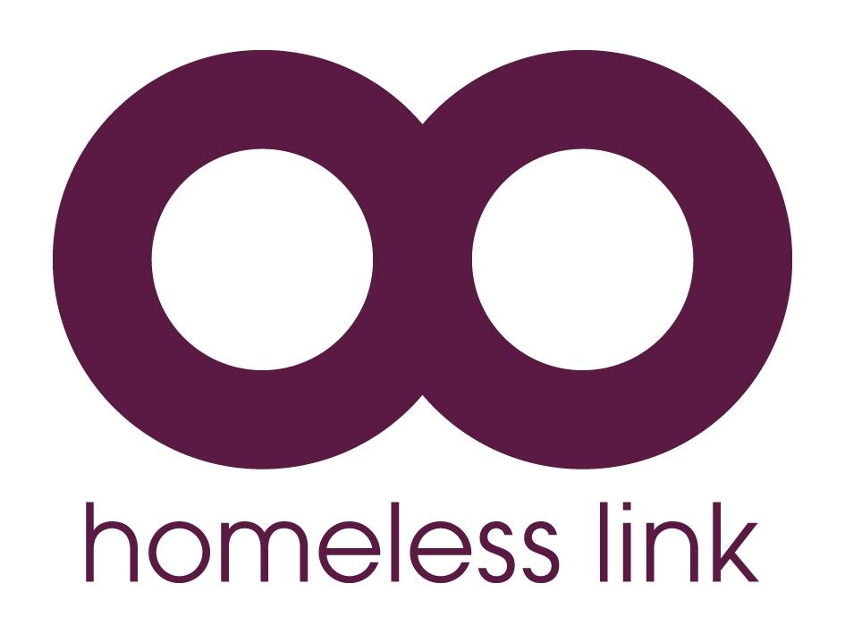

CALL FOR EVIDENCE:

EFFECTIVE APPROACHES TO HOMELESSNESS PREVENTION

Background

DCLG have commissioned Homeless Link to conduct research into successful models of homelessness prevention. The research will identify good practice, look at what works in homelessness prevention and present case studies that highlight effective working.

Preventing homelessness before it starts is essential for ending homelessness and ensuring people receive adequate support before they reach crisis point. It is also more cost effective in the longer term and can help avoid the negative impact homelessness has on other areas of life.

The Call for Evidence

As part of this research we are issuing a Call for Evidence of existing and emerging homelessness prevention practice that provides support to people at risk of homelessness. Support may help people to remain in their existing accommodation or access alternative accommodation. It may take a number of forms, including mediation, advice or financial support. We are interested in hearing about any approach that has helped prevent homelessness from occurring or resolved a person’s housing need, rather than models of practice which focus on helping people who are already homeless.

How to respond

Please share any examples of work being undertaken currently or previously, using the template over the page. These will be used to identify and highlight effective practice that could be replicated in other areas.

If you are engaged in multiple prevention activities, please complete a separate template for each activity. If the information in any of the sections is not available, please leave them blank.

Please return any examples by 30th September 2016.

If you have any questions about the research, please contact Rachel Hurcombe – rachel.hurcombe@homelesslink.org.uk / 020 7840 4418.

HOMELESSNESS PREVENTION CALL FOR EVIDENCE TEMPLATE
Name of your project/service. | Your Chance (Fair Chance Funded Social Impact Bond (SIB)).
Name/type of intervention. | Intensive floating support with young people aged 18-24.  The programme is specifically targeted at those harder to reach / chaotic young people who are struggling with the transition to adulthood and who may have dropped through the gaps of support offered.
Date intervention started (and ended if applicable). | Your Chance is a three-year project, which started in January 2015 and will run until December 2017. There are seven Fair Chance Fund programmes across the UK.
Location (i.e. local authority area). | Your Chance is active in Manchester City, Oldham, Rochdale and Royal Borough of Greenwich. We work with 216 young people in total over these four areas.
Summary: please tell us about your intervention, under the relevant headings. | Aims:  The programme aims to work with hard to engage young people to make a positive difference in their lives. Young people who were referred (referrals taken in first year only) were homeless or at immediate risk of homelessness (i.e. on an eviction notice); they also needed to have been NEET for at least four weeks prior to the referral being made.  The programme aims to build positive relationships with young people and support them in these areas, helping them access and sustain secure, safe accommodation, and provide opportunities in employment, education, training or volunteering.  Description of the homeless/housing problem it seeks to address:  This cohort of young people often come from generations of families who do not work and have low levels of education. These families may have received support under local authority schemes such as Troubled Families; they may have links with offender programmes / substance misuse or mental health services. Without appropriate support and intervention this next generation could be heading in a similar direction. They may already have had contact with the criminal justice system, abuse drugs or alcohol, have low levels of education or undiagnosed learning difficulty or mental health need. They are in a revolving door situation with their accommodation, having left home, moved in with friends or wider family then onto supported accommodation or in some cases their own flats. These arrangements have broken down for whatever reason and the young person is in danger of running out of options.  With the right, targeted support interventions, these young people can make positive changes to their lives – the support team works to stabilise the young person in accommodation and then focus on other areas of their lives where they would like to see some change.  Activities delivered:  The support team works dynamically with the young person – completely focusing on their needs and removing obstacles and barriers – from getting benefits set up or appropriate ID for a young person, to paying for private CBT sessions because the young person will not engage with statutory services. The team run regular activity sessions with young people such as running, hiking, ‘fun’ activities such as go-karting or bowling as well as holding hub drop-ins for young people to work on their CVs and job search. No two days are the same for the support team.  Who delivers it:  The support team is made up of support workers, and two employment, education, training and volunteering (EETV) workers.  Where it is delivered (i.e. homelessness service, family home, prison etc.): The service is based in a young persons drop in centre in Oldham and In an office of a similar project in London.
Target client group(s) (e.g. young people, care leavers, ex-offenders – please include all who can use the service if more than one target group). | Young people aged 18-24 including care leavers, offenders, those who use drugs or alcohol or who have a mental health need.
Partner organisations – who else is involved in delivering it? | Depaul delivers the service but we work collaboratively with other agencies in the locality such as accommodation providers, Employment, education, training or volunteering (EETV) providers,  DWP, Community Rehabilitation Companies and New Psychoactive Substances (NPS), mental health and substance misuse support services.
How is it funded? | Your Chance is funded through a Social Impact Bond (private investors), and payments for outcomes evidenced come from DCLG.
How much does it cost to deliver? | The cost for the three years of the programme is £1.1 million.
Outcomes: what are the outcomes for the intervention and how are they measured? | We receive outcome payments for moving a young person into accommodation and supporting their sustainment of accommodation for 3, 6, 12 and 18 months.  We receive payments for supporting young people in education and then if they complete this and go on to achieve a qualification (different qualifications are paid at different levels).  We receive payments for supporting young people into employment or volunteering and helping them achieve 6 / 13 / 20 / 26 sustainment for volunteering, and 13 / 26 weeks for employment.  All outcomes need to be robustly evidenced.
Has it ever been evaluated? Please provide more information about evidence of the intervention’s effectiveness in preventing/reducing homelessness and the methodology used to show this. If you have data on cost-effectiveness please include this here. Or please provide the evaluation report if this is available. | The DCLG has commissioned external evaluation of the programme which will be completed in the year after the programme ends. There is also a SIB Board who we meet with monthly and provide up-to-date data and statistics on the progress of the programme.
What would you say has been key to the intervention’s success and outcomes? Were there any barriers to implementation? | Due to the nature of working within a SIB we have been able to work more creatively with the young people - for example having a personalisation fund to support with rent and deposit bonds. We have also been able to change the programme as we have progressed and are constantly evaluating within the team. An example of this was changing one of the support worker’s roles to focus on employer engagement in the different areas so we could maximise the opportunities we were able to offer young people.  In terms of barriers to implementation, before the programme started we worked hard to get local agencies on board to support the project, recognising we needed to work in partnership to be able to achieve the outcomes for young people. The DCLG terms also required that we have local authority backing of the programme before it started and this was vital.
Would you be willing for this case study to be included in our report for DCLG? | Yes
Is there anything else about the intervention you think would be useful to share with us? | SIBs are still very new ways of commissioning services and local authorities are understandably nervous about implementing them but some of the early results from the Fair Chance Fund show the risks are worth in and the changes it can make to a young persons future are huge.
Please provide contact details for further information. | NAME: Simone Newman, Programme Manager  EMAIL: Simone.Newman@depaulcharity.org.uk  TELEPHONE: 07789981256

HOMELESSNESS PREVENTION CALL FOR EVIDENCE TEMPLATE
Name of your project/service. | Oldham Reconnect
Name/type of intervention. | Family mediation, parenting support and housing advice
Date intervention started (and ended if applicable). | From 02/04/2007 - current
Location (i.e. local authority area). | Oldham
Summary: please tell us about your intervention, under the relevant headings. | Aims:  To prevent homelessness and improve family relationships/communication. Provide knowledge of options open to young people if they are made homeless  Description of the homeless/housing problem it seeks to address:  Threat from parents/carers to make young people homeless due to behaviours in the home etc.  Activities delivered:  - One-to-one support sessions with both the young person and parent/carer  - Facilitated joint mediation sessions between the young person and parent/carer to draw up agreements for the way forward that would enable the young person to remain at home or move to appropriate accommodation in a planned way, avoiding crisis.  Who delivers it:  One Depaul UK worker  Where it is delivered (i.e. homelessness service, family home, prison etc.):  Mainly from the offices of Positive Steps, a local charity providing a number of youth focused agencies in the borough, although the project worker will meet with people where they feel comfortable, and is safe for them.
Target client group(s) (e.g. young people, care leavers, ex-offenders – please include all who can use the service if more than one target group). | The client group is 16-25 year olds at threat of or currently homeless. Oldham Reconnect also offers a spot purchase service for those young people not meeting the age criteria, often this service is used by schools for Year 10 and 11 students
Partner organisations – who else is involved in delivering it? | Depaul UK has an informal partnership with Positive Steps, a local charity who view the service as important to their work in the borough. All young people referred to Oldham Nightstop (see below for more details on Nightstop) also get referred to Reconnect which can help us to respond quickly and support young people to return home. Reconnect is closely linked with the Depaul UK Young Persons housing pathway in Oldham and can provide mediation between young people who live in Supported Accommodation and their parents.
How is it funded? | Oldham council commission Reconnect and have done since April 2007. As stated above we also receive sessional income from school and other services.
How much does it cost to deliver?

Outcomes: what are the outcomes for the intervention and how are they measured? | Outcomes are based on quarterly homelessness preventions. Homelessness is seen to have been prevented if mediation has enabled the young person to remain or return home for 6 months or longer (based on the old BVPI213). In agreement with our commissioners we also report on Temporary Preventions under 6 months where mediation is seen to have made an impact.
Has it ever been evaluated? Please provide more information about evidence of the intervention’s effectiveness in preventing/reducing homelessness and the methodology used to show this. If you have data on cost-effectiveness please include this here. Or please provide the evaluation report if this is available. | See evaluation from Homeless Link.
What would you say has been key to the intervention’s success and outcomes? Were there any barriers to implementation? | Working in partnership with other agencies; removing barriers to referrers by asking ‘how can we help’ rather than allowing barriers to be created such as ‘this doesn’t meet our criteria’ etc; adopting a person centred and whole family approach by including parenting support.  In our experience, if parents are able to adapt the way they communicate with young people and reflect on their own actions this leads young to make changes themselves. Traveling with families on their journey and having the freedom to not have to fit them into a model.  Challenges have been a reduction in available funding to develop the service since 2010.  In terms of barriers there was initial concern from the Homelessness Service about how Depaul UK would approach mediation due to past experiences with mediation. This was overcome by developing an open and honest relationship with a, ‘how can we help?’ approach in the early stages.
Would you be willing for this case study to be included in our report for DCLG? | Yes
Is there anything else about the intervention you think would be useful to share with us?

Please provide contact details for further information. | NAME: David Batchelor  EMAIL: david.batchelor@depaulcharity.org.uk  TELEPHONE: 01616219433 07811451648

HOMELESSNESS PREVENTION CALL FOR EVIDENCE TEMPLATE
Name of your project/service. | Depaul Nightstop UK
Name/type of intervention. | Emergency Accommodation
Date intervention started (and ended if applicable). | 1991 - current
Location (i.e. local authority area). | 33 towns and cities around the UK (a full list is available)
Summary: please tell us about your intervention, under the relevant headings. | Aims:  Nightstop’s aim is to ensure that no young person sleeps in an unsafe place. It prevents young people sleeping rough and is an alternative to the bed and breakfast accommodation young people are often placed in by Local Authorities in emergency situations.  Description of the homeless/housing problem it seeks to address:  Nightstop seeks to prevent a crisis situation turning into long-term homelessness and to ensure that young people are not in unsafe temporary living situations.  A recent research report by Depaul UK into the experiences of young people in temporary living arrangements after leaving their last stable accommodation: ‘Danger Zones and Stepping Stones’ has found that young people in have been exposed to serious harms whilst in temporary living situations including physical violence and drug related harms and alcohol misuse: “She kind of used to encourage me to take the drugs she was taking, like cocaine and stuff like that. I’ve never touched anything like that. I was thinking that I should take this because I’m in her house, she wants me to take it, and maybe she’ll have me stay for a bit longer if I do what she wants me to do.” (Grace, 19, South East).  Young people also described their temporary living experiences as having left them with poor and irregular sleep patterns, weight loss as well as extreme stress:“[Moving around] made me feel like I wasn’t myself anymore, it just didn’t feel... right, like I’m on anti-depressants now because of that.” (Reece, 17, North West).  The research found that young people often feel a strong sense of burden when relying on family, friends and acquaintances for a roof over their head, something that could be seen in several cases to draw them towards more dangerous arrangements such as staying with people they had just met, rather than with people whose help and support made them feel they were taking advantage. This has the consequence of keeping them trapped for longer in potentially dangerous temporary living situations: “ you know when you just feel like you’re putting pressure on the family, like their family, their mum and dad and that... they’re probably struggling themselves.” (Bethan, 21, South East).  The research found that supportive environments were most likely to be provided by smaller accommodation projects, or by friends or family, where: there was a strong relationship between the young person and those accommodating them; the host cared about the young person and their future; the young person did not feel like a burden and was willing to accept help; and the host supported the young person – practically and through knowledge and advice.  Activities delivered:  Nightstop’ provides free, safe, secure, emergency accommodation for single young people predominantly aged 16-25 in the homes of approved volunteer hosts.  It prevents young people sleeping rough and is an alternative to the bed and breakfast accommodation they can be placed in by Local Authorities in emergency situations, as well as an alternative to larger and often more chaotic supported accommodation for some of the younger and often more vulnerable young people in need of somewhere to stay. Young people are able to access Nightstop through designated referral agencies, these agencies carry out a face-to-face risk assessment to determine if the young person meets the referral criteria and can be placed with a Nightstop host. Once there they will be offered an evening meal, a chance to shower or have a bath, given clean clothes and the sole use of a bedroom for the night. The hosts are there also to listen to the young person should they wish to talk. Whilst a young person is staying with Nightstop, trained professionals are working with partners to find a longer term, safe place for them to move onto.  Who delivers it:  Nightstop UK is led by Depaul UK who lead the national network. The network is made up of 33 services, which are each delivered locally by partner organisations including YMCA, Barnardos, Action for Children, as well as local and regional housing or youth organisations, with Depaul UK running Nightstops in the North East, London and Oldham. This means the service can meet the needs of it’s community, as it’s delivered by local experts.  Where it is delivered (i.e. homelessness service, family home, prison etc.):  The homes of vetted and trained volunteer hosts in 33 towns and cities across the UK.
Target client group(s) (e.g. young people, care leavers, ex-offenders – please include all who can use the service if more than one target group). | Single young people aged 16-25
Partner organisations – who else is involved in delivering it? | 28 organisations deliver Nightstops nationally, all accredited and supported by the national network lead by Depaul UK. Organisations include national housing and youth charities, as well as local and regional community, housing or youth organisations.  In addition to the partner organisations we work with wider local partners who refer into the service, including local charities, FE colleges, GPs, Police, social services and housing services.
How is it funded? | Nightstop is a unique example of the voluntary sector, local authorities and private funders working together to respond to a local need - that of youth homelessness. Local Authority Children’s Services Departments have a statutory duty to provide a place of safety for homeless 16/17 year olds and Nightstop helps them to meet their statutory obligations to accommodate vulnerable young people, however it is central to the integrity of the Nightstop model that we also accept vulnerable young people who are directly referred by voluntary agencies (some Nightstops also accept young people who self-refer). Nightstop’s funding mix allows us to provide a safe and secure emergency placement service to Local Authorities and offer night placements to those young people who do not want to access the statutory homeless route but are still vulnerable and need emergency accommodation.  Nightstop is funded through a mixture of local and national funders. Each individual service is responsible for ensuring the sustainability of their service and have been successful with Big Lottery Funding, Local Authority funding, trusts and foundations, PCCs, corporate partners as well as local community fundraising.
How much does it cost to deliver? | Due to the fact its is a local service, Nightstop can cost different amounts to deliver in different geographical areas.
Outcomes: what are the outcomes for the intervention and how are they measured? | In 2015 Nightstop services in the United Kingdom provided over 13438 bed nights – providing 1602 young people with a safe place to sleep. 1131 young people were not able to be provided with a bednight due to either no host, or no suitable host, being available  Nightstop won a ‘Big Society Award’ in 2013 and Nightstop London won the 2015 Team London awards in ‘My Community’ Category.
Has it ever been evaluated? Please provide more information about evidence of the intervention’s effectiveness in preventing/reducing homelessness and the methodology used to show this. If you have data on cost-effectiveness please include this here. Or please provide the evaluation report if this is available. | The service has not been recently evaluated although there are hopes that an SROI will be done in the future
What would you say has been key to the intervention’s success and outcomes? Were there any barriers to implementation? | Nightstop is successful because it’s a community response to a local issue. The model is clear enough to support all young people, but allows for localisation, ensuring that whether young people are in rural Somerset, or central London they can be supported to Nightstop. Young people, vulnerable and young, can often end up in unsuitable accommodation that are lacking in support and surrounded by other risk-taking people. Nightstop places them with a positive role model, somewhere safe, and in a home unit that helps to re-gain their trust in adults again.  It is simple, and low cost in addressing the needs of young people, but it relies on good move on options. Unfortunately young people rely on Nightstop for longer now (8 nights on average) as we struggle to move them onto somewhere more sustainable. This constant movement and instability can be difficult.  One major barrier is funding of the service, and the cost to pilot it initially in an area. Seed funding would allow small local organisations to get the staff and volunteers in place, trial the service, and gain the evidence to approach longer-term funders.  Another is the misconception of what homelessness is. Fear is the main barrier to volunteering with Nightstop. We’d love to work with the department in helping dispel those myths. Young people who access Nightstop just don’t have the support network that so many of us do have.
Would you be willing for this case study to be included in our report for DCLG? | Yes
Is there anything else about the intervention you think would be useful to share with us?

Please provide contact details for further information. | NAME: Nicola Harwood  EMAIL: Nicola.harwood@depauluk.org  TELEPHONE: 02079391220

